Ithaca College
Department of Athletics – A&E Center
953 Danby Rd,
Ithaca, NY 14850

IN CASE OF EMERGENCY,
CALL Public Safety 607-274-3333 (911 or 4-3333 from any internal phones)
Use emergency phones located on the pool deck

For pool or Locker room issues call: Facilities 607-274-3225,
After hours call Public Safety to contact facilities

Aquatics Director and A&E Center Coordinator
Mike Ariel Office: 607-274-1068 email: mariel@ithaca.edu

INTRODUCTION

This safety plan, for the Athletic and Events Center pool has been developed to help insure proper bather supervision, operation and maintenance of the pool. In the event of an emergency, this safety plan will provide the information to carry out the emergency action plan. All individuals involved with bather supervision and operation/maintenance of the pool must become familiar with the information contained within this safety plan.

Part 6-1 NYSSC regulates swimming pools and where copies of this safety plan can be found.

ORGANIZATION & MANAGEMENT

Chain of Command

Emergency Calling Tree

Provost

Director of Intercollegiate Athletics and Recreational Sports
Susan Bassett
Address: 120 Athletic and Events Center
Office: (607) 274-3209 E-mail: sbassett@ithaca.edu

Aquatics Director and A&E Center Coordinator
Start Calling Tree: Michael Ariel
Address: 120C Athletic and Events Center
Office: 607-274-1068 E-mail: mariel@ithaca.edu
Cell:508-212-2130

Office of Facilities
Maintenance Staff
607-274-3225

Head Lifeguard

Supervising lifeguards

Lifeguards

LIFEGUARD DUTIES AND RESPONSIBILITIES

Job Descriptions
- Lifeguards-
  - Athletics Program Lifeguards are responsible for the safe and effective day-to-day operation of the swimming pool(s) and deck areas. While exemplifying the student employment service philosophy, lifeguards enforce facility policy, rules and regulations, prevent accidents, implement emergency action plans as needed, work assigned duties, attend staff meetings, and maintain high levels of physical and mental fitness as well as keep lifeguarding skills at optimum level of performance.
- Supervising Lifeguard- Supervision Level IIb,
  - Any time there are three lifeguards, or more, on duty at one time the Aquatics Director and A&E Center Coordinator will designate a supervising lifeguard. The supervising lifeguard will be in charge of establishing a shift rotation, lifeguard stations to meet the needs of the patrons, and adjusting lifeguard positions and staffing if need be. (Level IIb lifeguards are 18+ and have a minimum of 2 seasons of experience.)
- Head Lifeguard- Supervision level IIb
  - When the Head Lifeguard is on duty when there are more than 3 lifeguards on duty it is the default that the Head Lifeguard will also be the supervising lifeguard. The Head Lifeguard will assist the Aquatics Director and A&E Center Coordinator in lifeguard reviews, adjusting staff, positions, schedules, and assist with all in-service trainings. The Head Lifeguard will also be the initial emergency point of contact in the absence of the Aquatics and Strength & Conditioning Coordinator.

Minimum Qualifications
An individual must possess current American Red Cross certifications in the following areas:
- Red Cross CPR for the Professional Rescuer – Valid for the first year only, regardless of the duration of certification.
- Red Cross Lifeguard Training and or Waterfront Lifeguarding.

Job Requirements:
All indoor pool lifeguards are expected to fully cooperate with the following requirements and duties. The success of the program depends on positive professional conduct and attitude.
- Continually maintain safe and effective pool supervision and operation. No other activity can interfere with this requirement.
- Actively practice preventative lifeguarding strategies at all times while in the pool, on or off duty.
- Read and know the Lifeguard Manual, enforce and practice all pool rules and regulations.
- Lifeguards must actively maintain a ‘successful test out’ level of knowledge, skills, and fitness required to perform the duties of the job.
- All individuals in the water must be directly supervised by a lifeguard on duty. Never leave the pool unguarded.
- While on or off duty, never enter the water alone.
- Lifeguards must monitor the pool from lifeguarding stations, follow the rotation policy and, when appropriate, make adjustments to the lifeguarding stations and rotations to ensure proper supervision.
- When on duty a lifeguard's complete attention must be on the pool and pool area.
  - If approached by a patron with a question do not break pool supervision and direct them to the lifeguard at the ID table. If that is not possible answer the question in a polite concise manner or if that is not possible direct them to the Aquatics and Strength & Conditioning Coordinator.
- Observe individual behavior in the water. Communicate immediately to any patrons if their actions jeopardize their own, or other's complete safety.
- Honor your assigned work schedule and report dressed in uniform for work a minimum of ten minutes before the scheduled start of the shift unless otherwise stated.
- Lifeguards are responsible for maintaining current certifications needed to lifeguard
- Lifeguards must wear Ithaca College issued uniforms for all their lifeguarding shifts.

Duties
- Lifeguards must be in uniform, complete the necessary inspections and forms, on deck and have the pool ready for safe operation 10 minutes before their scheduled shift starts.
- If an unsafe condition is found and cannot be immediately and safely corrected by the lifeguards, call the Office of Facilities, and the Aquatics Director and A&E Center Coordinator Immediately, DO NOT OPEN THE POOL.
- Place pool signage in appropriate locations.
- For anyone to enter the water of the swimming pool, a lifeguard must be in the lifeguard chair on duty.
- If an accident occurs, call Public Safety (607-274-3333) and completely fill out an Accident Report Form (see Appendix A). This must be submitted immediately to the Aquatics Director and A&E Center Coordinator or the Assistant Director of Athletics of the A&E Center. Cell phones will be used for emergency purposes. The emergency phone numbers for Public Safety and contact people are posted by the check in desk. There is also a checklist of information that must be provided when phoning for emergency assistance and includes:
    - Name of caller
    - Location of emergency
    - Telephone number of facility
    - Type of accident (drowning, cardiac arrest, severe bleeding)
    - Required Assistance (ambulance, fire department, police)
    - Approach Route
    - Before hanging up, ask if further information is needed
- LAP SWIM – Two lifeguard minimum:
- At least 1 lifeguard will be on duty at the appropriate lifeguard station and have their full attention focused on the pool, for every 3,400 square feet of open pool.
- If pool attendance or activities exceed the abilities of 1 lifeguard, two lifeguards will be used at one time. When two lifeguards are used at one time, lifeguards will count the number of patrons on the hour and record the figure in the pool book after the shift has completed.
- When factors allow for a lifeguard on break, the lifeguard on break must check identification and keep an exact count of bathers. When bathers arrive at the pool, identification must be presented. The lifeguard ‘on break’ records the type of membership on the Daily Attendance Form (appendix B) The accepted types of membership are:
- Ithaca College faculty/staff and students - Ithaca College ID card
- Family of Ithaca College faculty and staff
- Friends of Ithaca College - Friends of Ithaca College must present their Friends Membership Card in addition to another photo ID. Two forms of ID Needed for Friends ONLY.
- The lifeguard ‘on break’ will also keep the pool deck clean, neat and free of obstructions that accumulate during pool use.
- Aquatic Classes ONLY – Students/patrons do not need to provide identification. In Emergency Situations the lifeguards will direct the instructor as needed to safely assist. The lifeguarding staff may assist the instructor in class set up BEFORE the course begins, before students enter the pool area only.
- The guards must not engage in activities that interfere with supervision of the bathers.
- Eating while on duty is not allowed. Eating is only allowed while at the check in table.

Substitution Policy
Once the schedule is published it is now the responsibility of the lifeguards assigned the shift to find staff when a schedule conflict arises. Staff emails go out frequently for assistance; it is the responsibility of the lifeguard looking for help to effectively and clearly communicate who exactly is covering for them to the staff, and the Aquatics Director and A&E Center Coordinator. This will avoid confusion and the double booking of a single individual for the same shift.

Non Emergency Situations (more than 24 hours notice)
  - If a lifeguard needs to find a sub for a scheduled shift it is their responsibility to find a replacement for their shift that is currently on staff. When there is more than a full 24 hours before the shift in question send an email to the staff

Emergency Situations (less than 24 hours notice) MUST Call Text
  - Emergency situations will arise, it is still the responsibility of the lifeguards to try and find a substitute. Lifeguards must make an effort to call and or text all staff members listed on their shifts sub list to find a sub. If a lifeguard is having difficulty finding a sub then they must contact the Aquatics Director and A&E Center Coordinator immediately AFTER attempting to contact those on the sub list so alternative actions can be taken. Examples include: Family emergency, personal injury or illness, etc.
Non-emergency, last minute; if a prior obligation has unexpectedly gone over time, causing a lifeguard to potentially be late, or to actually be late. It is the expectation that the lifeguard will text/call the Aquatics Director and A&E Center Coordinator “Pool” and the Aquatics Director and A&E Center Coordinator will either find a suitable temporary replacement or lifeguard themself.

Schedule changes
- When a lifeguard changes their scheduled shifts they must inform the Aquatics Director and A&E Center Coordinator so the permanent schedule can be updated.

Training, Evaluation, Observations
- In service staff meetings are required for all staff to attend and fully participate to keep skills and knowledge in peak condition. If an individual is not able to attend the normal in service time, they must attend the makeup time if offered. If both in service times, when available, are missed it will be considered a resignation. Frequent and periodic performance evaluations and observations may be conducted by the Aquatics Director and A&E Center Coordinator, Head Lifeguard, and supervising lifeguards to help ensure that skills are at their peak. The Aquatics Director and A&E Center Coordinator may also send staff emails with updates and recommendations, it is the duty of the lifeguards to read and implement these updates BEFORE their next shift.

Lifeguard Evaluation Forms
- Lifeguard Evaluation Forms are one tool used by the Aquatics Director and A&E Center Coordinator to provide a written record of performance. These evaluation forms may be used, in part, to help evaluate when possible; pay adjustments, hours, promotions, and position. This evaluation form may also include the performance of any skill or test required to perform any lifeguarding duties. If a lifeguard fails performances test, evaluation, and or, observation they will be placed on written warning and may lose their hours for two weeks. The Aquatics Director and A&E Center Coordinator will meet with the lifeguard at the beginning of their suspension, to discuss the details of their reprimand. Before the lifeguard can restart their hours they must successfully perform a FULL performance evaluation with the Aquatics Director and A&E Center Coordinator. If any lifeguard fails a second performance test, evaluation and or observation in the same academic year they will be terminated immediately.

Written Warnings
- Written warnings are issued when a lifeguard, or lifeguards, fail to execute the duties and requirements to successfully maintain safe and professional operation of the pool. Any issued written warnings may result in; immediate termination, suspension, decrease in pay (rate or hours), schedule adjustments, or may go on record as receiving a warning.

Resignation/Dismissal
- If a member of the staff resigns, they need to notify the Aquatics Director and A&E Center Coordinator two weeks prior to the resignation date. Automatic termination will result when any action taken by a lifeguard is negligent or places fellow lifeguards or pool users in a dangerous situation. A lifeguard whose performance which is found to be below standard will be written up and suspended, if improvement is not shown in the areas of concern, they will be dismissed. If a lifeguard is dismissed, there will be written notification and a meeting between the Aquatics Director and A&E Center Coordinator.

Lifesaving and First Aid Equipment and Uniform
Required lifesaving/first aid equipment must be available and in good condition when the pool is open. Equipment used during an emergency is to be replaced as soon as possible, if no longer found to be safe and effective all other equipment will be returned to its location.
First Aid Care should be provided in First Aid station located bleacher side mid pool, only when it is safe to move the victim there.
The following emergency equipment is available for use in the pool. Please familiarize yourself with the equipment and its location.
- 15’ Shepherd's crook is to be hung on opposite side of the pool from the stands.
- Rescue tubes are to be located at each lifeguard chair.
- The spine backboard with straps is to be at poolside.
- The 24-unit first aid kit with CPR mask is to be at poolside on each lifeguard stand.
- Each on lifeguard should have a First-aid fanny pack and CPR mask on their person.
- The AED is located by the south end of the pool next to the swim offices.
Lifeguard Uniform
- Each regularly scheduled lifeguard will be issued a Lifeguarding T-Shirt. Communication
Whistle Signals
- 1 Short Blast – to get attention of swimmer
- 2 Short Blasts – to get attention of another lifeguard
  - 2 Short Blasts with one arm in the air – Additional lifeguard(s) needed.
- 3 Short Blasts – Emergency – lifeguard leaving station
  - Water clearing procedure may need to be initiated.
- 1 Long Blast – top clear the water/ buddy check upon instruction of lifeguard
- 1 Long Blast with lifeguards arms in ‘x’ - missing swimmer
Staff should use the emergency phone (found at the south end of the pool) to summon Public Safety. If a cell phone is used, please ask to be transferred to the Ithaca College dispatch.

Rules and Regulations – Pool rules and regulation can be found in Appendix J.
When a rule is being broken:
- Contact the person breaking the rule, either contact directly (making sure that coverage of the pool is still being provided) or use whistle – use 1 short blast from the whistle and point to the individual who broke the rule.
- Explain the rule that is being broken and give a reason as to why the rule exists.
- If the same person continues to break the same rule: Contact person again. Explain rule again. In the case of children, inform parent or guardian and have them sit out of the water for 15 minutes.
- If the same person continues: Contact person. Instruct person that they must leave the pool for the remainder of the day.
- Lifeguard(s) have the authority to request that an individual leave the facility for not complying with the posted rules and/or lifeguard instructions. Record the name(s) and if possible the ID number(s) of that individual(s) requested to leave the area and should be logged on an incident report form and given to the Aquatics Director and A&E Center Coordinator and/or the Assistant Director of Athletics. If they do not comply after you have respectfully requested they leave the facility, inform the patron that Office of Public Safety are now being notified, and go make the phone call.

Supervision, Coverage, Rotation
- Lap Swim times - At least one lifeguard will be on duty at all times the pool is open for every open 3,400 square feet of pool not to exceed 5 x 8 foot wide, 25 yard lanes.
- Lap Swim Times -Two lifeguards will be on duty if at any time there are more than 30 people in the water or around the pool. Two lifeguards on duty may need to be used with far less attendance and patronage to safely monitor the pool and surrounding area. It is the responsibility of the lifeguard ‘on duty’ to make the determination for additional coverage before pool attendance exceeds their lifeguarding abilities.
- Lap swim two lifeguards - on duty shifts should not exceed 30 minutes in duration, at one location, unless cleared by the Aquatics Director and A&E Center Coordinator. For shifts longer than 1 hour it is highly recommended ‘on duty’ shifts last no more than 15 to 20 minutes at one location. In situations where more than two lifeguards are used at one time the Aquatics Director and A&E Center Coordinator will determine a rotation procedure to fit the event.
- The rotation procedure will be initiated by the ‘off duty’ lifeguard walking over to the lifeguard ‘on duty’ in accordance with the American Red Cross Lifeguard rotation process.
- Each chair/lifeguarding station will be equipped with a rescue tube, a whistle, and a first-aid fanny pack.
- Each lifeguard on duty will scan back and forth over their area of coverage. This must be done slow enough to see what each swimmer is doing. If a swimmer goes underwater, the lifeguard should watch until the swimmer surfaces prior to continuing the scan.
- Patrons must not be allowed in the chair or immediately in front of the chair.
- If at any point half of the pool section or overall facility capacity is unexpectedly reached PLEASE DOCUMENT THIS IN ADDITONAL COMMENTS.
- The lifeguard ‘on break’ at the check in table will clean and straighten the pool as needed during the shifts
- Unless otherwise scheduled, the maximum capacity for lap swim times with two lifeguards is 80 patrons and no more than eight, 25 yard lanes, not to exceed 8 feet in width.
SPA Coverage –
- When the spa is open, lifeguards will include periodic supervision and coverage. Lifeguards will inspect the spa every 30 min when open.
- Signage will be placed when the spa is closed for use. Lifeguards, Maintenance, and the Aquatics Director and A&E Center Coordinator will be responsible for these closures.
Opening, Closing Starting and Ending Shift Procedures

Pool Opening Procedures
First shift of the day Complete Steps 1 through 11.
Opening the pool midday --- Complete Steps 1,3, A, 7 though 11.
Starting shift with staff change --- Complete Step 5a only.
- Each lifeguard will be given access codes. Lifeguards are responsible for the proper use of their IDs and access codes. Any lifeguard found to be using the pool for personal use will be immediately dismissed. If an ID is lost, the individual must notify the Aquatics Director and A&E Center Coordinator immediately.
1. Enter the building through the East Doors ( the doors facing toward Bothroyd Hall)
2. Deactivate the alarm by entering the pool though the hallway next to the wet class room and entering in the appropriate code.
3. Enter the pool but keep the doors locked.
4. Remove and stow the pool cover, aquatic vacuum, clean and straighten the pool deck if needed.
5. Compete the Opening Safety checklist Appendix A located in notebook and fix any problems before opening.
- Check chemicals and record in book on attendance sheets BEFORE OPENING THE POOL or starting a shift. See Appendix
- Read comments and remarks in the pool book and look for any situations that may apply to the current shift. If possible speak with current lifeguard staff regarding any situations that may carry over.
- Check first aid kits daily. Report any items that need to be replenished or repaired to the Aquatics Director and A&E Center Coordinator.
7. Place safety equipment and pool signage around pool as needed
8. Only sections of the pool that will be under the direct supervision of lifeguards will be open. All other areas will be marked as closed with the use of pool signage.
9. During Lap Swim place check in table and ID Swipe in conspicuous location with movable floor depth signage.
10. Lifeguard(s) on duty will take their place.
11. The extra lifeguard will open locker room doors.

Closing the Pool Procedures
More than 4 hours. Complete Steps 1 - 9
Less than 4 hours – Complete Steps 1-5 and step 8.
Ending shift with continued coverage – Complete Step 5 only. Only use when other lifeguard arrives follows the rotation procedure and is ready to take over supervision. Otherwise complete steps 1-5 and 8.
1. Notify all swimmers 10 minutes beforehand that the pool will be closing turn off music if on.
2. Lifeguard ‘on break’ will pick up any trash on deck surface and check pool for foreign objects.
3. Ask patrons to exit the water and pool area through the locker room doors.
4. Lock all doors leading into the pool area. Once all patrons have left and doors are locked the lifeguard ‘on duty’ will now assist in closing procedures
5. Put unneeded safety equipment away, clean pool deck of unused items and sign out in the pool book.
6. Place the aquatic vacuum in the pool, place pool cover on, and turn off lights.
7. Leave through the locker room doors making sure there are no patrons. If there still are patrons in the locker room wait for them to leave in the Hall of Fame hallway.
8. Lock the locker room doors.
9. Activate the alarm in the hallway nearest the wet class room and notify Public Safety 607-274-3333.

Chlorine, pH testing, and Water Clarity
- At the opening of every shift, lifeguards are required to record the chlorine and ph levels and look for the main drain located at the bottom of the pool in the deep end. These values must be recorded on the attendance sheet chart found in the lifeguard notebook. If at any time the chlorine, pH and levels are found to be out of range (**with dual confirmation), or if the main drain is not clearly visible the pool must be closed, or remain closed and the Facilities Office must be notified. If the chemicals are found to be trending out of range call the Office of Facilities. If it is a minor problem that can be fixed quickly (less than 30 minutes), then follow the guidelines for a temporary pool closing. If the problem is severe, or needs a significant amount of time to correct, then follow the procedures for a permanent pool closing. Both procedures are discussed later in the manual.
**If the chemical display shows chemical levels are out of range, perform a physical chemical test for double confirmation. If there is a large discrepancy between the digital display and the physical test results, call the Office of Facilities.
Testing pH and Chlorine
- Store kit in a cool, dark place, away from heater.
- Store away from pool / spa chemicals.
- Follow directions precisely.
- Obtain water samples far below water surfaces.
- Take samples at same time of day.
- Rinse sample cells before and after each use.
- Hold reagent bottle in a vertical position when dispensing.
- Notify Aquatics Director and A&E Center Coordinator when testing chemicals are half full.
pH and Chlorine Levels for the pool
Test | REQUIRED RANGE | Call Physical Plant if: | Close pool if:
pH | ‍≥7.2 – ≤7.8 | At or trending towards required minimums or maximums | Outside of range
Chlorine | .6 - 5.0 |  | Outside of range
Chlorine: When pH is 7.8 or less, minimum free chlorine residual is 0.6mg/l
When pH is 7.8 - 8.2, minimum free chlorine residual is 1.5mg/l
Maximum free chlorine residual = 5.0mg/l
Maximum pH = 8.2
pH and Chlorine Levels for the SPA - IF temperature exceeds 104 degrees Fahrenheit close the SPA
Max capacity in Spa is 12 individuals.
Test | REQUIRED RANGE | Call Physical Plant if: | Close SPA if:
pH | ‍≥7.2 – ≤7.8 | At or trending towards required minimums or maximums | Outside of range
Chlorine | ≥1.5 - ≤5 |  | Outside of range
Chlorine: Maximum free chlorine residual = 5.0mg/l

NOTE: Lifeguards should call Facilities 607-274-3225 if they notice chemical levels and water clarity trending out of acceptable

Chemical Storage and Handling
- All handling and storage of chemicals should be done following manufacturer’s directions by the Office of Facilities according to their manuals. Good safety habits and proper handling of chemicals are essential for preventing a chemical accident. General safety rules should be established and prominently posted in the chemical use area.

General Guidelines include:
- Follow manufactures instructions.
- NEVER add water to chemicals; always add chemicals to water SLOWLY.
- Wear eye protection when handling chemicals to water.
- NEVER mix any chemicals with chlorine products. A dangerous chlorine gas could develop immediately.
- Always use a clean scoop when dispensing powered chorine as a potential fire hazard. .
- All Chemicals dispensing crocks must be clearly labeled.

Facilities – Certified Pool Operators
- Daily Inspection
- Main Drain Grate – To be secured to the bottom and not broken
- Pool Ladders to be firmly anchored to deck.
- Pool Doors – Self closing, self latching mechanism to be operational
- Water Clarity to be such that main drain is clearly visible
- Make sure covers are on the chlorine and acid crocks and the labels on the crocks are clearly visible.
- Drain and clean spa every other week. More often required if high usage.
- Increase chlorine level to 10.0, week after draining, ONLY when not in use. More often required if high usage.
- If shocking agent added please inform Aquatic Staff and place appropriate signage.
- Spa sign will be placed when the spa is being cleaned and/or closed.

Custodial
- Will call Public Safety 607-274-333 to notify them of their entering the pool.
- Custodial Staff will employ the buddy system (two individuals must enter together) when entering the pool area.
- Will notify Public Safety when they have completed their duties in the pool area.

Pool Instructors –
- Know the pool rules and regulations
- Read the Indoor Pool Safety Manual
- Know role in the event of an Emergency
- Report any unsafe condition to the lifeguards immediately.
- Before the instructor leaves the pool deck the class must clear the pool.
- Inform Aquatics Director and A&E Center Coordinator of any special requests or needs.
- Insure that pool and storage areas are cleaned after class.
- If a class is canceled inform the Aquatics Director and A&E Center Coordinator as soon as possible.
- Communicate any lifeguard requests through the Aquatics Director and A&E Center Coordinator only.

EMERGENCY PLAN
Chain of Command
Emergency Action Plan - Multi-Staff
The following procedures correspond to the flowchart entitled Emergency Action Plan – Multi-Staff (see Appendix I).
Accident or situation is a situation that demands immediate attention of the lifeguard(s).
- The lifeguard(s) realize that a victim is in need of help.
- The lifeguard must then notify the other lifeguards of an emergency situation. When the other lifeguards hear three short whistle blasts, the second lifeguard is responsible for covering the area of the lifeguard that left their station to assist the victim. If appropriate the lifeguard(s) should begin clearing the pool.
- The lifeguard must then decide whether to enter the water. It is not necessary for the lifeguard to enter the water if the victim can be reached with safety equipment. If the lifeguard must enter the water, proper rescue techniques must be utilized to ensure against any further injury to the victim. The second Lifeguard should contacts Public Safety (607-274-3333).
- If the lifeguard feels there is any chance of a head, neck or back injury, the lifeguard should make a cross with forearms to alert other lifeguard of such injury. Once contact is made with the victim, the victim should be brought to shallow water or onto the deck with skills appropriate to the event in which caused the accident. The victim should be immobilized and another lifeguard needs to notify Public Safety of this type of injury. The victim should not be moved further than is necessary.
- The lifeguards should evaluate the victim’s condition. If no injury has taken place, the lifeguards return to duty. Before returning to duty the lifeguard should caution the victim about changes in the water depth. Public Safety should be contacted immediately regardless of their apparent condition if any person has suffered an epileptic seizure in the water.
- In the case of an emergency, Public Safety should be contacted immediately by using the emergency phone box….locations to be determined. Do not delay. If there is an injury, the lifeguard(s) need to reassure and treat the victim until Safety arrives. When Public Safety arrives, they will evaluate conditions and determine if EMS is needed. The victim will be released if the condition does not require EMS. An accident report must be completed immediately. The Aquatics Director and A&E Center Coordinator along with Risk Management needs to be notified immediately.
- If EMS is needed, Public Safety will activate the EMS system. While waiting for EMS personnel to arrive, Public Safety will continue to administer care to the victim. Once EMS personnel arrive, EMS takes over responsibility for the care of the victim. Public Safety will supply any pertinent information regarding the victim to EMS personnel. The Aquatics Director and A&E Center Coordinator or Risk Management will contact Tompkins County Health Dept. in severe cases.
- All accidents/injuries must be reported to The Aquatics Director and A&E Center Coordinator. If an accident results in serious injury or death, the lifeguard must notify one of the following individuals, in order given. This must be done as quickly as possible, but only after proper care has been given to the victim.

Emergency Phone Numbers & Rescue Personnel
For all emergency situations call Public Safety at 607-274-3333.
Phone Tree - emergency situations
Call the following staff members in this order until you reach one of them. Leaving a message does not count as reaching someone.
Staff Member Telephone
Head Lifeguard (only for use when Aquatics Director and A&E Center Coordinator is unavailable)

Aquatics Director and A&E Center Coordinator: Michael Ariel
Office: 607-274-1068
Cell: 508-212-2130

Office of Facilities 607-274-3225

Public Safety and After hours facility issues 607-274-3333
Lifeguardss have a duty to report suspicious activities to Public Safety Immediately. If for whatever reason the situation does not permit itself to doing so text or call the Aquatics Director and A&E Center Coordinator or Head Lifeguard for assistance at which time Public Safety will be dispatched to the pool.

Incident Log and guidelines for filling out an incident report
All incidents that occur must have a written report. The lifeguard who handles the injury or incident must fill out an injury report form located in the Lifeguard Notebook (See Appendix H). This report form MUST include time, actions by various individuals, witness statements and equipment use. All incidents must be recorded on the injury log sheet and must include those that:
- Result in Death
- Require Resuscitation
- Require Referral to a Medical Facility
- Bather Illness Associated with Water Quality.
- These items must be reported to the local health department within 24 hours.
For major incidents, Public Safety should be contacted immediately by calling 607-274-3333 (4-3333) for internal phones).

For minor incidents, the report should be filled out and recorded on the injury log sheet. All injury report forms are to be given to the Aquatics Director and A&E Center Coordinator after the conclusion of the shift the incident happened. Remember when in doubt fill it out!

If members of the victim's family were not present at the accident, they will be contacted by Campus Safety. Safety will interview any witnesses to the accident as soon as possible. There will be a staff critique, which is a meeting of all staff members to be held as soon as it is practical. The accident, its probable cause, the rescue procedures and the actions of all personnel involved will be discussed and evaluated.

Any corrective action that needs to be taken will be implemented.

Access for Emergency Personnel
See Appendix G

Special Procedures

Bulkheads
- Before moving bulkhead(s) clear patrons from affected sections of the pool. Clear lane lines from the pool. Inspect the height of the movable floor to insure the bulkheads will not come into contact. Move the bulkhead(s) into position with no less than two lifeguards, move in appropriate lane lines, allow lifeguard(s) to get position, and then reopen the pool.

Movable Floor
- Before moving the hydraulic floor clear all patrons from areas 1 and 2 (see appendix C) of the pool. Inspect placement of the bulkhead to insure that it will not contact the movable floor while changing depths. Move lane lines, if necessary.
- If the movable floor is moved to a depth of 5 feet or less a rope and buoy will be put in place to designate the difference in water depth. In special circumstances (i.e. classes that may require it for safety) railings will be put in place to designate the drops off/change in depth of the moveable floor. Railings will not be used in water 3 feet or deeper, and must be removed before the floor is moved to any greater depth. Submerging the railings in the water below this depth could result in injury.

Sparging Unit
Only the Ithaca College staff can use the sparging system. Lifeguards should not use the Sparger unit.

Weather Conditions

Temporary Closing
- At the observance of thunder and lightning the temporary closure of the facility is at the discretion of the Ithaca College Lifeguards and or Aquatics Director and A&E Center Coordinator. When dealing with severe weather situations the pool will reopen 30 minutes after the last observance of the severe weather condition. If dealing with other factors such as the facility being in the path of weather warnings, the pool will be re-opened when the weather clears. If weather persists then the pool will be permanently closed for the day.
If there is a tornado or severe storm warning and the A and E center is in the path of the storm, DO NOT SEND PATRONS HOME. Bring them into one or both of the locker rooms and close the doors. Wait till the weather clears then send one lifeguard out to make sure the scene is safe for the facility to reopen or send the patrons home.

NOTE: Bathers are not allowed to remain in the pool or pool area while the pool is closed.
If information received via telephone or by Public Safety that conditions seem to be developing which suggest the pool should be closed, lifeguards are to follow these instructions.
- Inform the patrons that you have received a call from either Public Safety or the Aquatics Director and A&E Center Coordinator that the facility must be closed.
- Give patrons 5-10 minutes (if safe to do so) to get to the locker room, get dressed and report the recommendations made by Public Safety to the patrons.

Permanent Closing
If the pool needs to be closed permanently due to weather, emergency, or other factor please notify the Aquatics Director and A&E Center Coordinator immediately.

Missing Swimmer and Missing Person
If a patron is reported missing, a water search procedures shall be immediately initiated. Upon receiving the report of a missing person the water will be cleared immediately and a description of the individual and last location is to be determined. A designated person is to be assigned to stay with the individual reporting the missing person. Notify Public Safety immediately. Lifeguards will visually sweep and inspect the water, and will physically inspect under the bulkhead with a mask and underwater flashlight under the supervision of another lifeguard. Once the pool locker-room and surround area have been cleared the search will be turned over to Public Safety. The pool will remain locked and closed until the situation is resolved. Two lifeguards will stay behind in the pool.

Epileptic Seizures
If a person suffers a seizure in the water Public Safety should be called immediately regardless of their condition after the episode. transported to a medical facility regardless of apparent recovery. A person suffering a seizure should not be allowed in the water again for the remainder of the day.

Fecal Contamination
Fecal contamination of swimming pool water poses a potential risk of infection to bathers. Feces may contain pathogenic or harmful bacteria, viruses and parasites that are resistant to chlorine at concentrations found in a pool under normal operating conditions. Special precautions must be taken to ensure that the water is made safe for bathers. Swimming pool operators must respond differently to formed-stool and diarrhea in the swimming pool. Diarrhea may indicate that a bather is ill with pathogens such as the highly chlorine-resistant parasite Cryptosporidium. Therefore, more stringent measures must be taken to sanitize the pool when diarrhea discharges occur. The following steps should be followed when fecal contamination of a swimming pool occurs.

Formed-Stool (solid, non-liquid) – Call Facilities and follow procedure below minimum pool closure 30 minutes
- Clear the pool of all bathers.
- Call Facilities
- Using a skimming net or scoop, remove as much fecal material as possible from the water and dispose into the sanitary sewer. Clean and disinfect the net (bleach/chlorine solution will work) to prevent reintroducing fecal matter to the water.
- Spot treat the area of the pool where the contamination occurred with approximately 8-10 ounces of chlorine.
- Raise the pool water’s Free-Chlorine residual to 2-3 ppm (pH 7.2-7-5). *Take chlorine readings from multiple locations around the pool to verify that all areas have reached 2-3 ppm.
  - Close the pool for 30 minutes.

Diarrhea (liquid stool) – Call Facilities and follow procedure below
- Clear the pool of all bathers.
- Call Facilities
- Using a skimming net or scoop, remove as much fecal material as possible from the water and dispose into the sanitary sewer. Clean and disinfect the net (bleach/chlorine solution will work) to prevent reintroducing fecal matter to the water.
- Based on pool volume, calculate the amount of chlorine that is needed to establish 20 ppm of chlorine* in the pool. - 2/3 quarts of 12% sodium hypochlorite or ¼ pound of 65% calcium hypochlorite per 10,000 gallons pool water will raise the free chlorine residual by approximately 2 ppm.
- Add the correct amount of chlorine to the pool. Chlorine may be added by hand around the swimming pool. Maintain the pH between 7.2 - 7.5.
- Keep the pool closed for 12.75 hours at 20ppm of chlorine. **Continue to operate the filter and disinfection equipment during this period.
- After 12.75 hours, backwash filters thoroughly.
- Make sure that the chlorine concentration in the pool is within acceptable levels (0.6 ppm - 5.0 ppm) before allowing bathers to enter the water.
Pool closure time is dependent on the level of free chlorine present in the water. The following combinations of Free Chlorine residual and pool closure time provide the same level of protection against disease transmission and can be substituted in lieu of 20ppm for 12.75 hours.
FREE CHLORINE RESIDUAL* CLOSURE TIME**

15 ppm 17 hours
10 ppm 25.5 hours
5 ppm 51 hours

Blood Contamination
Blood discharge into swimming pool water poses very little risk to bather health when the swimming pool's water chemistry and chlorine levels meet the requirements of the State Sanitary Code Subpart 6-1 "Swimming Pools." The chlorine (or bromine) that is already present in the pool quickly deactivates pathogens that may be in blood. As a result, there have been no documented cases of blood-borne disease transmission from swimming pool water. If blood contamination of a pool occurs, the following steps should be taken.
- Test the pool's water chemistry and chlorine (or bromine) levels to ensure compliance with State Sanitary Code section 6-1.11(c).
- If chlorine (or bromine) levels are satisfactory no further action is necessary.
- If disinfectant level does not meet the minimum level required for pool operation,
the pool must be closed and chlorine (or bromine) added until levels are satisfactory.

Additional Athletic and Event Center Policies

Capacity of Facility
Full capacity for the A and E pool is 475 people. The maximum capacity for lap swim times with two lifeguards guarding the pool is 80 patrons and no more than 11, 25 yard lanes, not to exceed 8 feet in width. Depending on the number and activity of the patrons during lap swim, more lifeguards may need to be on duty. Additional lifeguard at the check in table will be responsible for keeping track of the number of bathers in the pool. If at any time the pool reaches full capacity, the lifeguards should notify the other lifeguard that the pool is at full capacity and that that no else let into the pool until others bathers leave.
Capacity op the pool will be based on one Lifeguard covering a maximum of 3,400 sq/ft (5, 25 yard lanes.)
Spa – max capacity 19 people
Pool – max capacity 475
Pool area 1,723 people
Appendices

Appendix A - Safety Checklist

Lifeguard:_______________________ Date: __________ Shift Time: ____________

Yes No Lifesaving Equipment

___ ___ Lifeguard Stations are strategically located on deck near edge of pool.
___ ___ Shepherd’s crooks backboards, reaching poles, and rescue tubes are
In assigned locations.
___ ___ RESCUE TUBES – check straps making sure it is free of a tear or nicks.
___ ___ Backboard straps – Untwisted, free of knots or kinks
___ ___ Backboard buckles – No cracked or chipped, check to make sure buckles hold and then release.

Pool and Deck Areas

___ ___ All deck areas are in safe condition.
___ ___ The decks are free of standing water.
___ ___ Vasa’s and power racks pushed up against the wall.
___ ___ Starting blocks are all placed down in the shallow end.
___ ___ Special rules and regulations such as those on using the diving boards are
posted in appropriate locations.
___ ___ Water clarity is such that the main drain is clearly visible on the bottom of
the pool from the pool deck.
___ ___ All pool markings (depth/warning signs) are clearly visible.

Lockers Rooms

___ ___ All bather signs for pool users are displayed, outdated signage is discarded
___ ___ All walls and ceilings are in safe condition.
___ ___ All lamps light when the switches are turned on.
___ ___ Chlorine and Ph are at legal levels.
___ ___ First Aid kit is fully stocked.
___ ___ Petty cash is counted.
___ ___ Pool is free of debris.
___ ___ Lane lines are in place.

Comments:

Appendix C – Pool Sections
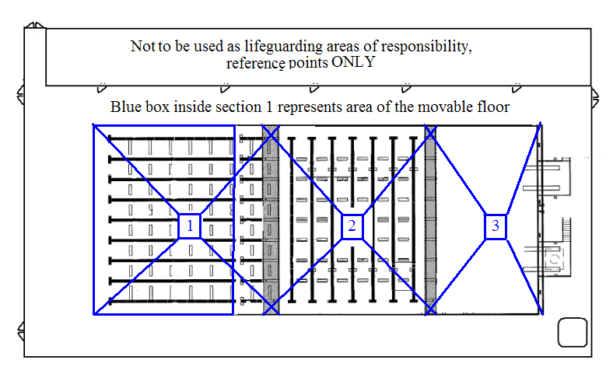

Appendix D – Lap Swim Set up
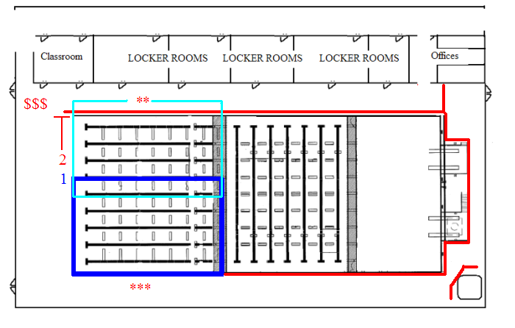

Red Line indicates signage informing patrons “section of the pool is closed” and to see the lifeguard at the check in table.
Blue boxed area is the default area that will be open for lap swim, NOT TO EXCEED 3,400 square feet.
Light blue boxed area 2nd lifeguard area of responsibility when two lifeguards are used.
The numbers indicate the order that additional lanes will be open if attendance requires.
If lane marked “2” is needed two lifeguards will need to be so the whole section of the pool will be opened.
$$$ indicates check in table location.
***default lifeguarding position.
** secondary lifeguarding position

Appendix E – Swimming and Diving Practice
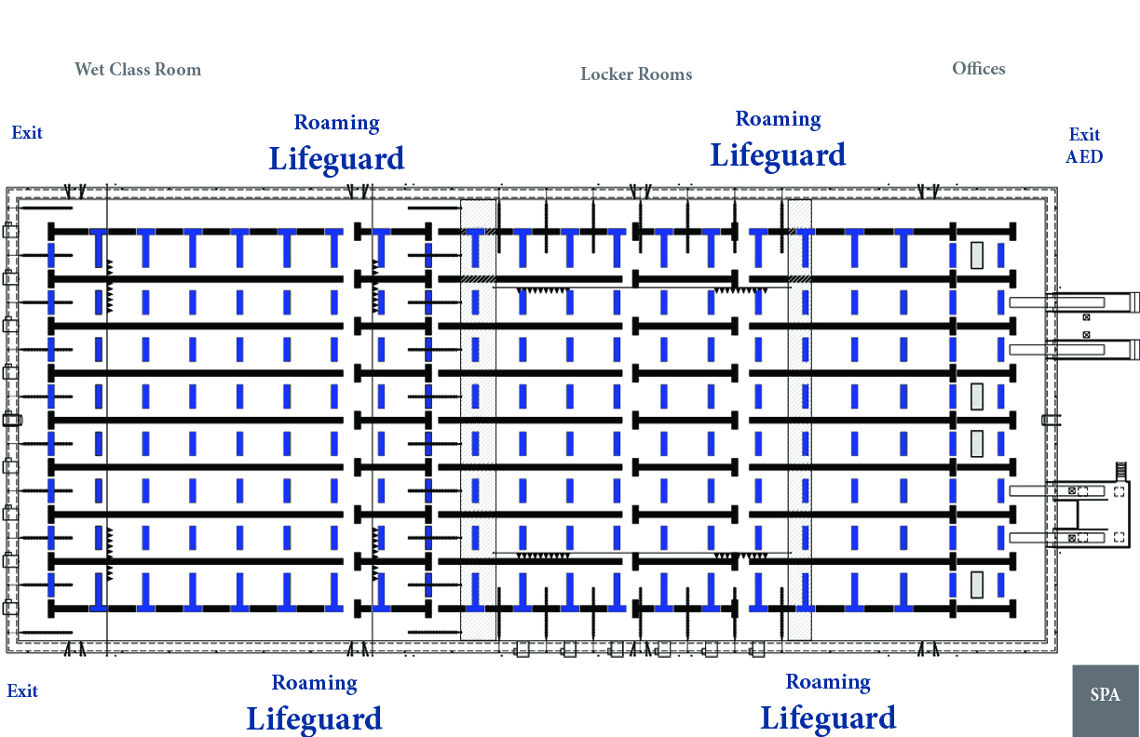
*Note this is when the pool is at max capasity, otherwise 1 to 3,400 sq ft rule shall be implemented.

Appendix F - A & E POOL - Emergency Evacuation Route

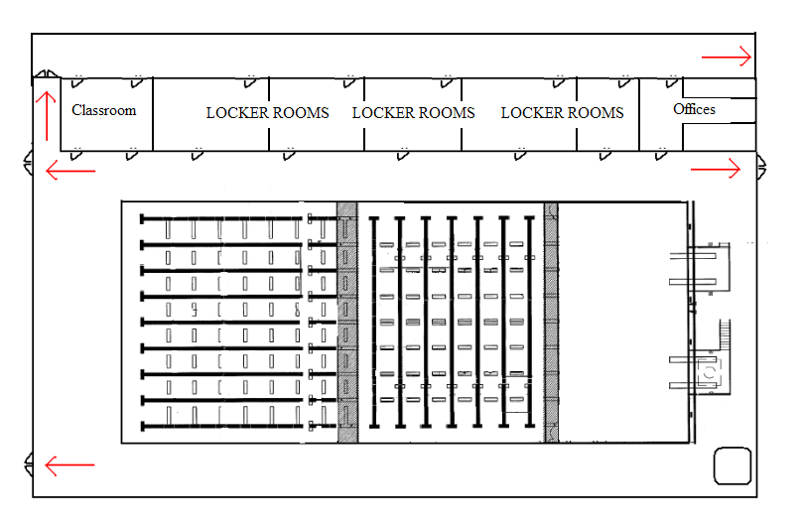

Appendix G - A&E Pool Emergency ACCESS route
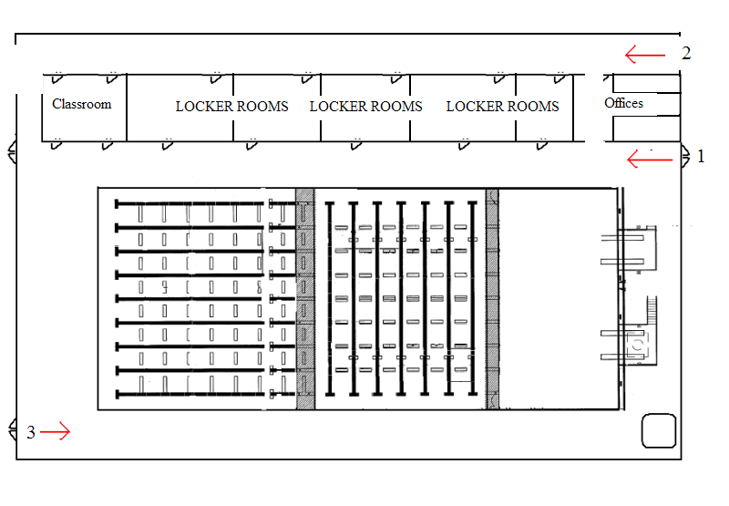

- Entrance (1) – main access point
- Entrance (2) secondary access point, locker-room Hall of Champions accident
- Entrance (3) Access point

Appendix H - INJURY REPORT FORM

ITHACA COLLEGE
INDOOR POOL INJURY REPORT FORM
Date: Time:

Injured person contact information: PRINT CLEARLY
First Name: _______________________________ Last Name: ____________________________

ID Number or SSN:

Affiliation: (circle one) Student Faculty/Staff Alumni Volunteer Visitor

Phone # (with area code): ________

Street Address:
City: ______________________________ State: _________________ Zip: _____________________

Please indicate where injury occurred:

Describe the injury and how it occurred: (nature and location)
___________________

_____________________________________________________________________________________
_____________________________________________________________________________________
Activity participating in (if sport related include team name/sport):
Sports Club __________________________________________
Intramural __________________________________________
Class __________________________________________
Athletics __________________________________________
Other __________________________________________

Has the person ever experienced the above injury? If yes, please explain.

_____________________________________________________________________________________

_____________________________________________________________________________________

_____________________________________________________________________________________

_____________________________________________________________________________________

First aid administered: (if any)

_____________________________________________________________________________________

_____________________________________________________________________________________

_____________________________________________________________________________________

_____________________________________________________________________________________

Emergency personnel contacted: _____Yes _____No (if yes, please explain)

_____________________________________________________________________________________

Witness’ Name (print clearly) and witness’ description:

Staff on Duty (PRINT FULL NAME CLEARLY): __________________________________________

Make sure to have additional pages printed, signed, and dated by author.

_____________________________ ____________________________
Signature of Injured Person Signature of Staff on Duty
Copy to:
- Health Center
- Risk Management
- Aquatics Director and A&E Center Coordinator
- Human Resources (if employee)
Rev. July 2011

Appendix I - Emergency Action Plan Multiple Staff Flow Chart
Accident/Situation

Lifeguard Awareness

Victim Recognition

Lifeguard Reaction (contact Campus Safety)

Lifeguard Enters Water (notifies 2nd Lifeguard) 2nd Lifeguard takes over total Coverage
Clear pool if needed
NO YES

Lifeguard Contacts Victim Lifeguard Contacts Victim

Victim to Safety

Victim Ok?

Yes No

Lifeguard returns to duty Lifeguard calls for help

Victim Given First Aid

No EMS Needed? Yes 2nd Lifeguard or support staff clears water

2nd lifeguard or support staff notifies Safety
Victim Released

Safety Calls EMS

EMS Takes Over

Chain of Command notified

Witness Interviews

Reports Completed

Corrective Action Taken Staff Critique
Appendix J - Indoor POOL Policies/Rules
Indoor POOL Policies/Rules
- The lifeguards warnings, rules, suggestions, and signs MUST be obeyed at all times.
      - Lifeguards and Aquatic Staff have authority to remove any individual from the facility without warning for any behavior that they feel is unacceptable or is harmful to other patrons at the pool. Additionally Lifeguards and aquatic staff can restrict the number of patrons using the pool, and sections of the pool, at any time if deemed necessary.
- Only use this facility during posted hours of operation. Entering the water without a lifeguard present and on duty is strictly prohibited; persons using the pool without the direct supervision of the lifeguard on duty are TRESSPASSING. The pool is CLOSED if and/or when lifeguards are not on duty.
- A valid Ithaca College ID is REQUIRED to use the pool EACH VISIT and must be presented to the lifeguarding staff at the check in table before entering the water.
- Unless there is a situation that requires immediate attention do NOT converse with the lifeguard(s) on duty. Any questions or concerns should be directed to the lifeguard(s) off duty, at the check in table, or to the Aquatics and Strength & Conditioning Coordinator.
      - Do not stand directly in front of any Ithaca College Lifeguard or station.
- Guarding chairs, rescue, and first-aid equipment will be used by the Ithaca College Lifeguards ONLY.
- THERE IS NO SUBSTITUTE FOR ADEQUATE SUPERVISION. Children under 16 years of age must be accompanied to the bathing facility by a parent or guardian, (an adult who is responsible for the children and their behavior.)
- Apparel warn in the pool must be clean swim wear that covers any private areas including buttock, pubic, and breasts. NO CUT OFF PANTS.
      - Small Children (babies) MUST wear diaper and rubber pants.
      - Street shoes are not allowed on deck.
- Swimming aids or floatation devices
      - For Children - US Coast Guard Approved Flotation devices ONLY. Needs to be used with parent supervision, not as a substitution.
      - Flotation devices can be restricted or prohibited at any time for any reason without warning and must be approved by the lifeguards EACH visit BEFORE use. Prior approval is not grounds for future approval.
      - If an approved floatation device is used by an adult they can only use the PFD where they are able to easily touch the bottom of the pool.
- Persons with communicable disease (example; colds, flu, eye infections) or infections conditions should NOT use the pool.
      - Persons with open wounds and sores should NOT use the pool.
- Pollution of the swimming pool is prohibited. Urinating, discharge of fecal matter, expectorating or blowing the nose in any swimming pool is prohibited in New York State.
- Unnecessary roughness, pushing, horseplay, running, jumping is prohibited.
- Shallow Water - Diving in the shallow end is prohibited, No Diving (for pools with water depths less than 8 feet) Standing front dives ONLY from water depths of 9 feet or greater in designated areas ONLY.
      - The use of starting blocks and diving boards are prohibited, and for the Athletic Teams use only.
- Individuals who jump or dive into the pool must look out for swimming in their landing area before jumping or diving from deck. In case of an accident the person diving or jumping is at fault.
- Hanging on the lane lines is not permitted.
- No swimming under the bulkhead or moveable floor at any time. Only authorized personnel are allowed to use bulkhead.
- No Alcohol, food, or chewing of gum is permitted in the pool or locker room area.
      - Alcoholic beverages are prohibited. Individuals under the influence of alcohol and or other non-prescription drugs are prohibited from using the facility.
- Glass, glass containers, or breakable objects are prohibited in the pool, pool deck, and locker room areas.
- Smoking is prohibited in the pool area.
- No non-service animals/pets allowed.
- All accidents and injuries must be reported to the lifeguard immediately.
- Participants MUST shower before entering the pool.
- At the observance of thunder and lightning temporary closure of the facility is at the discretion of Lifeguarding staff.

The following are simple etiquette guidelines that we use at the A&E Center Pool.
• Please notify the other swimmers before entering the lane.
• Please circle swim; Circle swimming is when you always swim on the right side and follow others in the lane. (note: two people splitting a lane and swimming on either side is acceptable when pool is in 25 yard configuration).
• Obey lane speed (i.e. fast swimmers in fast, slow/aqua joggers in slow)
• If you want to pass someone, tap them on their foot.
• Be aware of others in your lane – if faster let them go first, if slower give them 5 –10 second lead.
• Only swim in a water that you are comfortable – (i.e. don’t go in 50M if you can’t swim a length without stopping).
• Please use the bathroom before entering the pool – no urine, feces, spitting, blowing of nose, or other bodily excretions in the pool.
• Please do not be loud in the pool area - no shouting or inappropriate noise in the pool.
• Please return equipment after use (i.e. kickboard, pull buoys, etc…).

If you have any questions or do not understand a guideline, please speak to a Lifeguard who will direct you towards a supervisor.

