

Operations & Safety Manual

**2016 Lake George Marathon Swim**

**Sanction #036-W001**

**Individual and Relay Swims**

Saturday, September 17, 2016 – Sunday, September 18, 2016

“Diane’s Rock”

Ticonderoga, NY

To

Public docks

Lake George Village, NY*



*Preferred route is Ticonderoga to Lake George Village (north to south). If winds are strong from the south the swim will be reversed and conducted Lake George Village to Ticonderoga (south to north).

|  |  |  |  |  |  |  |  |  |  |  |  |  |  |  |  |  |  |  |  |  |  |  |  |  |  |
| --- | --- | --- | --- | --- | --- | --- | --- | --- | --- | --- | --- | --- | --- | --- | --- | --- | --- | --- | --- | --- | --- | --- | --- | --- | --- |
| **Basic Information** | | | | | | | | | | | | | | | | | | | | | | | | | |
| Name of Host Club | | | | | | Lake George Marathon Swim | | | | | | | | | | | | | | | | | | | |
| Name of Event | | | | | | 2016 Lake George Marathon Swim | | | | | | | | | | | | | | | | | | | |
| Event Location | | | Lake George, New York | | | | | | | | | | | | | Event Dates | | | | September 17-18, 2016 | | | | | |
| City | Lake George Village | | | | State | | | | New York | | LMSC | | | Adirondack | | | | | Zone | | | | Colonies | | |
| Length of Race | | | | | | | 32 miles | | | | | | | | | | | | | | | | | | |
| **Key Personnel** | | | | | | | | | | | | | | | | | | | | | | | | | |
| Event Director | | | | Robert Singer | | | | | | | | | | | | | | | | | | | | | |
| Cell Phone | | 518-791-1295 | | | | | | Home Phone | | | | 518-761-6605 | | | | | E-mail | | | | [marathon@/lakegeorgeswim.com](mailto:marathon@/lakegeorgeswim.com) or  N5442T@gmail.com | | | | |
| Referee | | Deborah Roberts | | | | | | | | | | Phone | | | 518-796-9156 | | | | | | E-mail | | | debaroberts@gmail.com | |
| Safety Coordinator | | Ruth Dietrich- Quinn | | | | | | | | Phone | | | 518 222-2399 | | | | | E-mail | | | | RDietrich@glensfallsymca.org | | | |
| **Water Quality**  Lake George is known for exceptional water quality. See <http://www.lgpc.state.ny.us/water_quality.html> for an overview of water quality and potential water quality issues. The lake is tested to comply with Department of Health standards as an unfiltered drinking water source. Swim organizers will confer with the Lake George Park Commission prior to the event to determine if any events like an oil or fuel spill or severe weather have compromised the water quality. | | | | | | | | | | | | | | | | | | | | | | | | |
|  | | | | | | | | | | | | | | | | | | | | | | | | |
| **Technical Meeting and Pre-Event Athlete’s Meeting**  The swim is scheduled to start at 3 PM on Saturday, September 17, 2016. A mandatory safety briefing with swimmers, kayakers, boat captains, and observers will be held by “pod” at half hour intervals starting at 2 PM on September 17. If the race starts in the north the briefing will be held at the Mossy Point Boat Launch. If the swim starts in the south, the briefing will be held at the public docks along Beach Road in Lake George Village. This meeting will review the starting procedures, kayaking orientation, required equipment, night operations, communications, risk management, assessment of swimmer condition, and responsibilities for each party. It is expected to run 2 hours. Except for updates for weather or any last-minute changes, this Meeting is not expected to be a full briefing. Before arriving at Lake George, participants are expected to read and understand the rules and safety procedures described in the Participants’ Guide (“Guide”), and to verify their understanding of this Guide by successful completion of an online quiz with a 100% score. | | | | | | | | | | | | | | | | | | | | | | | | |
|  | | | | | | | | | | | | | | | | | | | | | | | | |
| **Pre-Event Officials Meeting (required)**  September 17, 9:30 AM. This group will include the Event Director, Safety Coordinator, Referee, Pod Leaders, and Head of the Timing Booth at the finish. The referee will describe how the start, kayaker exchanges, relay changes, and finish will be recorded. In a separate meeting July 8, 2016, representative enforcement officers from the Lake George Park Commission, Warren County Patrol, and the EMS and warming tent personnel met to discuss emergency procedures. The conduct of the event was discussed and safety concerns were shared. The emergency actions, evacuation routes, and emergency communications were discussed. | | | | | | | | | | | | | | | | | | | | | | | | |
|  | | | | | | | | | | | | | | | | | | | | | | | | |
| **Pre-Event Athletes Meeting (required)**  The swim is scheduled to start at 5 PM on Saturday, September 17, 2016. | | | | | | | | | | | | | | | | | | | | | | | | |

|  |  |  |  |  |  |  |  |  |
| --- | --- | --- | --- | --- | --- | --- | --- | --- |
| **Event Conditions** | | | | | | | | |
| **Race Day Conditions** | | | | | | | | |
| Expected air temperature | | | 40-60°F | | | Expected water temperature | | 66-70°F |
| Combined air and water temperature | | | | | 106-130°F | | | |
| Wetsuits | Not Allowed | | | | | | | |
| Body of Water | Lake | | | | | | | |
| Water Type | Fresh water | | | Course | | | Open | |
| Description of how agencies will control the traffic while swimmers are on the course | | | | | | | | |
| The “course” is the entire 32-mile length of Lake George. The event is planned after Labor Day, when boat traffic drops dramatically. In the narrow navigation channels at the north end of the Lake and in the Narrows, swimmers and kayakers will be advised to stay on the shallow side of the navigation and obstruction buoys. In the open sections of the lake kayaks will be near the swimmers and equipped with horns and flags to alert boaters. The powerboats associated with each swimmer will be instructed to “protect” the swimmers from other traffic. In addition, two enforcement agencies will be on the Lake to maintain safety. These agencies, who both have police authority, are the Lake George Park Commission and the Warren County Sheriff’s Office. These agencies will participate in the safety briefings and may offer additional advice to us. They will be on the course during the day, but will only be on a standby basis at night. All our kayaks, swimmers, and powerboats will be marked with lights to enhance nighttime safety. They will be outfitted with orange safety flags for daytime operations. When the Lake George Park Commission and the Warren County Sheriff’s Office are on patrol, they will be loaned one of the race radios that the powerboats will have for communication. Cell coverage is pretty good over most of the course, and telephones will be available as backup communications and for nighttime emergency communications with the agencies. | | | | | | | | |
| Expected water conditions for the athletes (marine life, tides, currents, underwater hazards) | | | | | | | | |
| Lake George is exceptionally welcoming for swimmers.  **Wind and Waves**. Although 32 miles in length (north to south), it is only about 2.5 miles wide at its widest. The dominant westerly winds only represent a 2.5 mile fetch, and a ring of mountains around the lake mitigate all but the strongest winds. However, the north and south basins can represent an unobstructed fetch of 15 miles, rendering the potential for significant wave-swept shorelines if the winds are northerly or southerly. Northerly or southerly winds can raise waves up to three feet. Unlike ocean waves, these waves produced by gusty and swirling winds coming over mountains develop waves that are uneven in height and frequency. The result is a constantly changing chop that is challenging to swim through, particularly if the swimmer encounters waves head on. These waves also can be challenging for kayaks. This risk will be minimized by having the flexibility to reverse the direction of the swim. Another way we will minimize impacts of waves and chop is our planned start time at 5 PM. The winds almost always lighten overnight.  **Rocks.** The shallow waters may contain rocks that approach or break the surface, but the visibility is so good (20-30 feet) that these obstacles are easy to avoid in daylight. At night, the kayakers need to keep their swimmers just inside of the warning buoys to avoid rocks. Running into a rock is unpleasant, but not dangerous unless waves are high. In that case kayakers will be advised to keep the swimmers away from the shoals.  **Wildlife**. Freshwater fish do not pose a hazard. Very rarely rattlesnakes have been seen swimming across the Lake. This has been reported once in the last ten years and the snake was intent on making progress. No swimmer has ever been bitten by a rattlesnake in Lake George. Another problem for swimmers can be “Swimmer’s Itch,” or “Duck Itch.” This skin rash is caused by the larvae of a parasitic fluke that has a complicated lifecycle that includes parasitic infections in waterfowl and snails, with free-swimming larvae that seek appropriate hosts. When the larvae encounter a human they burrow into the skin. Since humans are not an appropriate host the larvae die, leaving an itchy, red, raised area that is much like a mosquito bite. The symptoms disappear in a couple of days. Symptomatic relief is available with hydrocortisone cream. The larvae are generally encountered near shore, where snails live, and in areas where people attract ducks by feeding them. | | | | | | | | |
| Course Markings and Start and Finish | | | | | | | | |
| The Start (or finish if the course is reversed) will initiate from the boat dock and Snug Harbor Marina in Ticonderoga. Swimmers will jump off the dock and swim about 50 yards to “Diane’s Rock,” a prominent rock that marks the end of the navigable channel at the north end of Lake George. Our escort boats will warn any non-participating boaters of the event and kayakers will escort the swimmers. The swim will be started in “pods” of 4-6 swimmers to minimize confusion. Each pod will start 30 minutes behind the preceding pod. Escort powerboats will stage about a half mile to the south, near the Mossy Point public boat launch. When the swimmers pass the powerboats will proceed to Black Point, about two miles south of the start. At that point the Lake widens out and powerboats and kayaks can assemble near their swimmers. If the swim finishes in Ticonderoga, Diane’s Rock will be marked with a pair of inflatable buoys that mark the finish line. Swimmers will be picked up by their powerboats.  2015-09-12 08.22.01.jpg  Diane’s Rock, proposed start/ finish of the swim. Inflatable buoys will be placed to mark the start/finish line. The Snug Harbor Marina will be the assembly point. It is about 50 yards behind and to the right of this vantage point  2015-09-12 08.53.41.jpg  Snug Harbor Marina (north), proposed assembly area for the start/finish of the swim. Diane’s Rock is about 50 yards behind and to the left of this vantage point  Village waterfront.jpg  View looking west of the public docks in Lake George Village. The start/finish will be marked by two large inflatable buoys. A stepladder will be tied in place to help swimmers exit.  Finish of course in Village.jpg  View looking northward from one of the docks in the photo above. The large land mass in the distance is the base of the Tongue Mountain Range, about 15 miles north. The main channel of the Lake narrows and turns to the right.  quarter mile start.jpg  Example of using two inflatable buoys to mark as start/finish from another of our open water swims. Note the lifeguard at the end of the dock and safety kayakers on the course. | | | | | | | | |
| Turn /Intermediate Buoys height | | | | Not applicable. There will not be any course markings | | | | |
| Start /Finish | In Water | | | | | | | |
| **Feeding Stations /Feeding Plan** | | | | | | | | |
| There will not be any special feeding stations. Each swimmer or relay team will have a powerboat escort. This boat will carry all the feed for the team or swimmer. In accordance with Marathon Federation rules, feed will be tossed to the swimmer from the kayak support. The kayak will be resupplied when kayakers switch. Relay swimmers can feed when they are on the powerboat, resting between their one-hour swims. The swimmers will be advised to leave some nutrition at the finish tent as well. | | | | | | | | |
| **Event Safety** | | | | | | | | |
| **Medical Personnel** | | | | | | | | |
| * A warming tent will be set up at the finish. It will be staffed by an EMT or MD, or PA with emergency safety training. Tim Ward, a PA in the Glens Falls Hospital Emergency Department, is managing this station. * Several agencies have agreed to provide safety/emergency support. They will be on the course during the day and on call for emergencies. These agencies include * Hague Fire Rescue & EMS will provide an on-site EMT equipped with first aid, an AED and oxygen. EMS be managed by ambulance Captain Renee Swinton, 518 543-8035, [swintonrenee@yahoo.com](mailto:swintonrenee@yahoo.com)). Hague is on the west side of the lake, about seven miles from the north end. * Hague Fire Rescue & EMS will provide a fire rescue boat. They may choose to stay on their dock or patrol the course. This rescue boat is managed by Fire Lt. Jon Hanna (518 543-6451, [bowhaler@gmail.com](mailto:bowhaler@gmail.com)). * Town of Bolton Fire Department. One of the EMS personnel in this service, Anne Green, is serving as “EMS Coordinator” for the event. * The Warren County Sheriff's office will be asked to have a marine patrol unit on-call or on site when available throughout the swims. This will be arranged through Lt. Kevin Smith at 518 743-2500. * The Lake George Park Commission has agreed (Joe Johns, enforcement, [JJohns@lgpc.state.ny.us](mailto:JJohns@lgpc.state.ny.us) ; Dave Wick, Commissioner, [dave@lgpc.state.ny.us](mailto:dave@lgpc.state.ny.us) 518-668-9347) to provide a patrol boat during the entire event. The primary role of the Sherriff’s patrol and the Lake George Park Commission patrols will be to police the course and advise non-participating boaters of the event, but they also have emergency medical training. | | | | | | | | |
| **First Responders/ Lifeguards** | | | | | | | | |
| * The Safety Coordinator for the swim is Ruth Dietrich-Quinn. She is a full-time, head lifeguard at the Glens Falls, NY, YMCA. She is YMCA and ARC trained and is an approved lifeguard and water safety trainer for the YMCA. She intends to be on the course for the entire event. Many of the volunteers and event personnel also have safety training. She or another lifeguard will be stationed at the start and at the finish. * All the agencies listed in the box above have First Responder personnel on their patrols. | | | | | | | | |
| **Safety Plan (Relays and Individual Swimmers)** | | | | | | | | |
| * The nearest hospital at the north end of the Lake is Moses-Ludington Hospital 1019 Wicker St, Ticonderoga NY (518) 585-2831. The nearest medical facility, and primary regional trauma center, is Glens Falls Hospital, Glens Falls, NY (100 Park St, Glens Falls, NY 12801, (518) 926-1000) The Emergency Departments of both facilities will be informed of the event. In the event of an emergency, the ambulance crews will decide to which facility they should travel. This decision depends on the nature of the emergency, the travel time, and the capabilities of the emergency. * The Safety Coordinator will be on the course and available via radio and telephone. Her boat will be in the pack of swimmers and will move toward the finish as swimmer’s approach the end of the swim. She will be in radio contact with safety and medical personnel in kayaks and event managers on land, and have access to the First Responders and other emergency personnel. * The Independent Safety Monitor will serve as an observer for compliance with the safety plan. He will be in radio contact with the Event Coordinator, Safety Coordinator, and safety & medical personnel in kayaks and event managers on land. * Each swimmer will be accompanied by a kayak. The kayaker’s primary role is the first line of safety monitoring. The kayaker will wave a signal flag (daytime) or flashlight (night) at any non-participating boat that is getting close. If necessary, the kayaker will signal the swimmer to move or change course for safety reasons. Kayakers must be within voice communication of a powerboat with radio communication. Kayakers must carry a whistle or signal horn. The kayak will maintain station about ten feet from the swimmer, with the kayaker’s body in line with the swimmer’s head. The kayaker will provide navigation clues to the swimmer by paddling toward or away from the swimmer to “steer” the swimmer. For the individual swimmers, the kayaker will provide “feed,” usually a liquid or gel, on regular intervals. It is best if the kayaker and the swimmer have worked together as a team so the kayaker knows the intervals and knows how to assess the swimmer’s condition. The kayaker will talk with the swimmer before the swim to discuss strategies for route selection, feeding, and signals. * Each swimmer shall have a powerboat support boat. Boats shall be small, open boats. At a minimum they must be equipped with a boarding ladder and lights for night operations. Power boats must be inspected and tagged with a Visual Inspection Control Seal at an inspection station prior to launching in Lake George. See <http://lgboatinspections.com/>and <http://www.lgpc.state.ny.us/PDF/LGP%20-%20Revised%20regs%2012-12.pdf>. A speed limit from 9 PM until 5 AM of 25 MPH will be strictly enforced. The daytime speed limit is 45 MPH. Power boat captains must be familiar with and comply with all Rules and Regulations from the Lake George Park Commission available at <http://www.lgpc.state.ny.us/rules_regs/646_2.html>. The powerboat will provide a place for relief kayakers and teammates for the relay. The powerboat will be available in case of a required evacuation or early end to the swim. Power boats should not be used to escort the swimmer. Powerboats should stay at least 50 feet from swimmers and downwind of swimmers except during relay exchanges and changing of kayakers. During these periods **powerboats shall approach the swimmer or kayaker with the engine idling (no turning prop)**. * Each support powerboat shall have a crew of two, the Captain and the Observer. The Captain shall be familiar with boat operations and navigation, and is the final authority for any issues dealing with the safety of his crew, the passengers, and the kayak and swimmers. The Observer shall be trained to operate the communications equipment in the case of incapacitation of the Captain. The powerboat shall carry a relief kayaker and other members of the relay teams. Each powerboat shall not exceed the capacity of the boat, and payload must be available for the kayaker and the swimmer. If the capacity of the boat would be exceeded by the equipment load, full relay team, observer, kayakers, and swimmers, some personnel will be off-loaded to the “pod leader” boat (see below). The Observer shall be responsible for the location of the kayak and swimmer at all times, and shall record the approximate location and time of entry of each relay team member. The Observer shall report any non-compliance with the Rules of Marathon Swimming to the Referee. * Many places in Lake George, in particular near Ticonderoga (north end) and the Narrows (mid-lake), the swimmers and kayaks may take a direct line that transits shoals too shallow for power boats. Channel markers are red and green. Going north toward Ticonderoga (the lake outlet), the red buoys are on the left. Returning south toward Lake George Village, away from the outlet, the red buoys are to the right. It is the responsibility of the power boat captain to safely navigate through the shallows. Power boat captains are urged to use Navionics Boating USA, a $9.99 software package, that will display a marine chart and the boat’s location. * Each “pod” of 4-6 swimmers, kayaks, and powerboats, shall be assigned a “pod leader” powerboat. This boat shall provide notifications to non-participating boaters of the presence of swimmers ad kayaks in the water, shall enhance communications via radio relays or moving between swimmers and the shore, and shall be available to move relief kayakers, supplies, or other duties to or from the shore or other boats. These boats shall also be used to transport the event managers (Event Director, Safety Coordinator, and Independent Safety Monitor). * There may be times when a kayak has to leave station for a few minutes to make a radio call or to look at a chart. Swimmers shall be briefed prior to the swim to continue on course until the kayak catches up. These excursions should never be for more than a minute. * There may be times when a powerboat has to leave their post near the kayak. This could be because of navigation hazards, equipment problems, or to talk briefly with other boats. During exchanges of kayakers, if the Pod Leader is available, duties of watching the swimmer for a few minutes may be shared with the Observer. The kayaker shall be informed of this departure from station. Powerboat Captains must exercise extreme caution while operating near swimmers. | | | | | | | | |
| **Emergency Plans** | | | | | | | | |
| An emergency is any event or situation that could lead to serious injury or death of any participant, volunteer, or spectator if action is not taken. Types of emergencies that may impact the Lake George Marathon Swim include (1) medical emergencies, (2) boating accidents, (3) vehicular accidents, and (4) weather-related problems.   1. **Medical emergencies:** Anyone can be stricken with a sudden onset illness, such as sudden cardiac arrest, a heart attack, insulin shock, food poisoning, or other suddenly debilitating illness. Each participant (swimmers and volunteers) must disclose any potential medical conditions about which they are aware that could leave them incapacitated. The powerboat Captains and Observers shall review these disclosures for their swimmers, kayakers, and each other. In the event of a medical emergency, the onshore First Responders shall be contacted and if advised by the First Responders, evacuations shall proceed. 2. **Boating accidents and prevention:** Boating accidents may include collisions with other boats, collision with rocks or other hazards, fires, “man overboard” situations, or striking of a swimmer with the boat or a prop. This endurance event will result in tired participants. Any participant (swimmers or volunteers) must be prepared to call it a day and say “I need a break” during the event. Furthermore, it is the duty of the boat Captain to cancel the swim for their escorted swimmer or team if, in their judgment, fatigue becomes a hazard. All powerboats shall be equipped with cushions or pads and one or more sleeping bags or bedrolls for people to rest. ***No form of alcohol or illegal drug may be on any vessel involved in this event.***   If a boat is incapacitated following a collision or engine problem, the Event Coordinator shall be contacted. It is possible that another powerboat may be able to take the place of the stricken vessel, crew can be brought onto a new boat, and the stricken vessel can be recovered for repair.  Each powerboat shall be equipped with an approved fire extinguisher. A fire onboard a boat with fuel is an immediate emergency and all passengers and crew must be evacuated, even if that means immediately leaving the boat for the water. The Captain should be prepared to evacuate if the fire cannot be immediately contained. **Smoking is not permitted on any powerboat during this event.**  All personnel on the deck of a powerboat must wear a personal floatation device at night, and during transfers to kayaks. If a crew member or observer falls overboard, a buoy shall be thrown to them to not only provide floatation but also to help mark the person. One person shall be designated by the Captain to watch the swimmer while the Captain maneuvers for pickup. At all times the safety of the swimmer and kayaker must be considered as well. Striking a swimmer or kayaker with a moving prop is a life-threatening situation. It is to be avoided by keeping powerboats away from swimmers. When swimmers must approach the boat to exchange relay swimmers or to end the swim, the engine must be in neutral when the boat approaches the swimmer.   1. **Vehicular Accidents.** This event is of course a swim, but a lot of driving will take place. It is an hour drive from Lake George Village to Ticonderoga on winding roads. Drivers must obey all traffic laws and be alert to deer, other wildlife, and pedestrians on the roads, particularly at night. Insurance and conduct on the roads is the sole responsibility of the driver. 2. **Weather-related problems and Cancellation.** Weather problems can be sudden storms that bring high winds and waves, turnover of cold water caused by winds, discharge of cold water from runoff after heavy rain, lightning, or very cold air temperatures. At the discretion of the Event Director, the Safety Coordinator, or the Independent Safety Monitor, the Lake George Marathon Swim may be cancelled before the swim or at any time during the swim. An individual boat captain is also authorized to cancel the swim for the swimmer or team that the captain is escorting if conditions are considered dangerous. The assessment of danger can be made based on the weather, condition of the boat, or condition of the swimmer or kayak team. The start may be delayed to allow for weather to pass or for equipment problems. A delay of the start may result in shortening the time until the cut-off for finish, at the discretion of the Event Director or Safety Director. A partial list of conditions that could lead to cancellation include: 3. **Observation of lightning.** Either direct observation of lightning flashes or observations of lightning on internet services (e.g. <http://www.lightningstorm.com/explorer.html>) that is imminently threatening. 4. **Sustained winds >28 MPH (25 kts).** Winds of this strength can be very dangerous for kayakers, and very challenging for swimmers and powerboats. A peak gust at this strength may be tolerable, depending on duration and direction of the gusts; the discretion of the race officials is available. 5. **Water Temperatures <60.0°F.** See Thermal Plan. 6. **Cold Air and Water, if the sum of Air Temperature and Water Temperature is <115°F.** Conditions with cold water coupled with cold air prevent relay swimmers for warming up between swimmers and will take a toll on individual swimmers.   **Cancellation**: Reimbursement of entry fees will not be available  **Emergency communications**: Each powerboat will be equipped with a two-way radio and a cell phone. The two-way radios will provide a network of reliable communications with the other boats and the first responders along the shoreline. The cell phones are convenient but there are known “dead zones” on the Lake that make cell phones a backup-only form of communications. Each kayak will be equipped with a GPS device that will broadcast its location. This will allow event managers at the finish tent to track the swimmers (actually their kayakers). A phone list will include radio frequencies and phone numbers for all boat Captains, First Responders, the Event Director, Safety Coordinator, Independent Safety Monitor, Referee, and staff in the Finish Tent. During the mandatory pre-event safety briefing, radio protocols will be established. Briefly, each radio call will proceed as demonstrated in the following examples. | | | | | | | | |
| **Swimmer in Distress.** | | | | | | | | |
| **Identification.** The first challenge is to identify when a swimmer is in distress. The kayak escorts are the most likely observers to identify a swimmer in distress. Powerboat crews may also see the signs of swimmer in distress.  **Training**. Although many of the kayak escorts are veterans of supporting other swims, and may know their swimmer very well, some will be new to this support role. In particular, most of the relays will be using team members as kayak support for other team members. Consequently training of kayakers, Observers, and Boat Captains must take place. This training will take place by having all kayakers, Observers, and Boat Captains read short descriptions of monitoring for the signs of a swimmer in distress and the emergency procedures if distress is identified. Each of these participants shall sign and return this “Swimmer in Distress” handout (see Addendum B) and return it to the Safety Coordinator or on line with their liability waiver.  In accordance with Addendum B, all Observers will complete the “stroke count” form (Addendum C) to track swimmer performance. | | | | | | | | |
| **Radio Protocols** | | | | | | | | |
| Radio Protocols Example, Swimmer in Distress | | | | | | | | |
| Party Calling | | “Swim, Hague EMT” | | | | | | |
| ID of Caller | | “Anne Green, EMS Coordinator” | | | | | | |
| Location of Caller | | “about one mile north of Hague” or “west channel of the Narrows” | | | | | | |
| Body of call | | “Swimmer is in distress, disoriented and confused but responsive; we’d like to proceed to an evacuation point.” | | | | | | |
| Reply | | “Hague EMT, Swim Event Director, Have the boat proceed to the Fire Department Dock in Hague.” | | | | | | |
| Confirmation | | “Swim, Hague EMT, Event Director, I will direct them to the Fire Department Dock in Hague, Please let me know the status when you pick up the swimmer, Out” | | | | | | |
| Radio Protocols Example, Transport of relief kayaker | | | | | | | | |
| Party Calling | | “Swim, Pod Boat 2” | | | | | | |
| ID of Caller | | “Boat Swimmer Jane Smith” | | | | | | |
| Location of Caller | | “North end of Long Island, west side of island” | | | | | | |
| Body of call | | “One of our kayakers needs to get ashore, we’ve arranged for a relief kayaker named John Jones to meet us at Yankee Yacht in Diamond Point. Can you come to us, pick up our kayaker, and go to Yankee Yacht to make the exchange? We will provide you with cell phone numbers and directions when you get here” | | | | | | |
| Reply | | “Boat Swimmer Jane Smith, Pod Boat 2, We are on our way to Yankee Yacht, ETA 15 minutes.” | | | | | | |
| Confirmation | | “Pod Boat 2, Boat Swimmer Jane Smith, Our ETA is ten minutes, we will have our lights on and will let you know which dock we get to. Out.” | | | | | | |
| General Comments on radio and cell phone usage. | | | | | | | | |
| 1. Use text messages and cell phones for routine reports and non-critical calls. 2. Keep your calls short. We can have a lot of people wanting to use the radio at once. Especially if the weather gets bad and multiple swimmers or boats have problems, don’t clog up bandwidth—think about what you are going to say before you start talking. 3. Identify yourself and who you want to talk to. Speak slowly and carefully. Most radios have about a half second or more before they start transmitting. Press the button and wait, or say a “stalling” phrase like “Swim.” 4. Use the same radio “handles.” All escort powerboats are “Boat Swimmer Jane Jones” or “Boat Team Albany.” Kayaks will identify themselves the same way: “Kayak Swimmer Jane Jones,” or “Kayak Team Albany.” If you say “Joe, this is Jim,” you are likely to have three “Joe’s” trying to answer at once. 5. At the end of the radio call, both parties should say “Out” so that others know the airwaves are free. [1] 6. Use useful location descriptors. Don’t say “I’m just off the point.” If you know the name of the Point say, “about half mile west of Assembly Point.” If you don’t know where you are say “Unsure of my location, about two miles south of the last clump of islands in the Narrows.” 7. If you have an emergency, START your call with “Emergency,” or “Mayday.” Don’t hesitate to call an emergency if you need special handling or services. If someone else calls an emergency or Mayday, do not jump into the dialogue unless you can provide important support to those handling the problem. Do not use the radio for non-essential calls until the emergency is resolved. Keep the airwaves open for the emergency. 8. Do not try to provide diagnoses. Note the example above: “Swimmer is in distress, disoriented and confused but responsive…” The example did not say, “Swimmer seems to have hypothermia.” You should wrap the swimmer like it may be hypothermia, but it could be dehydration or any number of other illnesses. Leave the diagnoses to professionals.   **Evacuation Procedures**  Evacuation may be required of an individual swimmer or volunteer, or the whole race may be closed if weather becomes threatening. Each boat captain should use their judgment, but general procedures for evacuation are:   1. Swimmer must board the powerboat. 2. Kayaker must board the powerboat. 3. Kayak to be lashed to transom or onto deck. Smaller boats may not have room for kayaks; in that case kayaks to be taken in tow. 4. Boats with full crew shall proceed to an evacuation point. These egress points are shown in the attachment. In the case of threatening weather, the egress point shall be the closest marina marked on the attached map of egress points. ). If it is a medical emergency the First Responders shall direct boats to the appropriate evacuation point. If she is available, the medical teams shall be coordinated by Anne Green. | | | | | | | | |
| **Thermal Plan**  Lake George is known for quick changes in weather. The mountains that ring the Lake make it difficult to see weather coming. Air temperatures could be in the 30’s at night but more likely in the low 50’s, with daytime temperatures reaching anywhere from the 40’s to 70’s. Water temperature will probably be 65-72F (see Addendum A). The intended course, from north to south, will be reversed if winds over 15 MPH are forecast from the south.   1. USMS Rules for Open Water Swims dictate that:  A swim shall not begin if the water temperature is less than 60° F. (15.6° C.), unless heat-retaining swimwear is required of all swimmers or a USMS-approved thermal plan is in place. 2. A swim in which heat retaining swimwear is required of all swimmers shall not begin if the water temperature is less than 57° F. (13.9° C.) unless a USMS-approved thermal plan is in place.   Water temperatures will be measured at a depth of one foot near the start, the finish, and in the Narrows on September 17, 2016. If any of these readings are below 60.0°F the race will be called off. The coldest temperature recorded by the Darrin Fresh Water Institute at numerous surface stations in Lake George during the first three weeks of September was 62.5°F.  The following measures will help to avoid and mitigate impacts to swimmers and crew from cold:   1. To increase swimmer preparation before the event, we will screen all applications. If individual swimmers or swimmers on relays with 2-3 swimmers have only swum in water temperatures in the upper 70’s through mid-80’s, we will not accept their applications until they complete a distance swim greater than 15 miles for individual swimmers and 10 miles for low number relay swimmers (2-3 swimmers) in temperatures below 68°F. Team members in relays with four or more swimmers need to demonstrate experience of completing an open water swim in the last three years of at least four miles in water under 72°F without a wetsuit. 2. To reduce swimmer exposure to hypothermia, we would cancel the entire event if temperatures are below 60°F. To minimize the chances for hypothermia in the expected conditions (average water temperature is 68°F), each relay team will be required to bring at least one sleeping bag and a waterproof tarp to wrap the bag. When relay swimmers leave the water they will spend a shift in the sleeping bag, with a teammate if they are really cold. All crew and relay swimmers will be urged to bring warm clothes and a thermos with warm drinks. If the weather forecast calls for rain all crew and relay swimmers will be told to bring rain gear. **Alcoholic beverages will be prohibited!** 3. To mitigate and treat symptoms of swimmer hypothermia, we will have trained medical personnel in a “warming tent” at the finish. They will have thermal blankets and insulated blankets. The “warming tent” will be an enclosed space with a warming bed and space heater. Protocols used for onsite treatment of hypothermia will be developed by medical professionals and appended to this Safety Plan. | | | | | | | | |
| **Night operations** | | | | | | | | |
| The swim will start late afternoon and end late afternoon the next day. This puts most of the swim at night. Day length will be just under 12 hours, so the course will be very dark for most of the race. This choice was made for two main reasons: 1) We did not want to start or finish at night, and 2) there is much less boat traffic at night  On September 17, 2016, the moon will rise at 6:45 PM and set at 6:26 AM. The nearly full moon will help to see land and obstacles. The sun will set at 6:02 PM for the start of the swim and it will rise at 5:37 AM. There will be some light all night from the moon.  Conducting the swim at night does add some special challenges.   1. It is harder to see the swimmers. All swimmers will be required to fix at least two battery lights to their suits and one on their goggle straps. The organizers of   this swim have had good luck with lights like the one pictured here. Thhttp://ecx.images-amazon.com/images/I/61RggltY2JL._SL1038_.jpge batteries last for at least 12 hours and they are very visible. We also will make use of “glow sticks” to mark swimmers. These lights will also be used to mark the kayaks. A large flashlight stuck into the back or front of a kayak will also help to light up the kayak for the swimmer to see. Powerboats must comply with standard coast guard lighting requirements.   1. Some swimmers may be uneasy swimming at night. Getting comfortable swimming at night is an acquired attribute. During the application process, we will inquire about experience swimming at night. For any swimmers who are at all uneasy, we will develop a training plan for them to get in several hours of night swimming before the event. They will have to confirm their compliance with the plan in writing before the swim. 2. Navigation can be challenging at night. Each powerboat will be given a chart that shows the major features of Lake George, all the channel markers, and the obstruction warning buoys. We hope to have an application for smart phones that will overlay GPS position onto a navigation chart. In any case, the slow speed of a swimmer should make navigation less threatening. In addition, the pod leader boats will be led by Captains who are very familiar with the navigation through the narrow channels of the Narrows and other hazardous areas that may be encountered at night. | | | | | | | | |
| **Accounting for Swimmers** | | | | | | | | |
| With up to six swimmers on relays, 14 relay teams, and 14 individuals swimmers we expect upwards of 80 swimmers. The Referee, Deborah Roberts, will institute procedures to “check in” and “check out” all the swimmers. At the start and finish, she will record entrance to the course on a simple form that includes columns for *Name, Time In, Location of egress, Time Out*, for each swimmer. Boat captains will notify her of any swimmer who does not finish and is taken to shore by boat. In the event of an evacuation of the course because of weather or other condition, the boat Captains shall notify the Referee where they make landfall and confirm that all parties are safely ashore and that they have arranged land transport for the swimmers and crew.  **Missing Swimmer**   * All swimmers will be required to provide an emergency contact name and number at registration. * If a swimmer is reported missing and last seen in the water:  1. The EMS Coordinator will contact the Fire boat and EMTs to activate any search and recovery protocol. 2. The EMS Coordinator will direct kayakers, lifeguards and volunteers to canvass the course and the shore. 3. Concurrently, the Event Director will manage Pod Leaders to attempt to contact the emergency contacts, support team, and swimmer via cell phone and public address. 4. All swimmers and powerboat Captains are reminded before the event start that they must report to the nearest event official if they withdraw from the race. | | | | | | | | |
| **Public Outreach** | | | | | | | | |
| Lake George can be a very busy lake, although boat traffic is greatly diminished after Labor Day. Nonetheless, a public outreach effort will be undertaken to make residents and the boating public aware of the race. The goal is to have any boats steer clear of the swim area while the event is in progress. These initiatives include:   1. **Notices** in the Hague Chronicle, Lake George Mirror, Glens Falls Chronicle, and the Glens Falls Post-Star with information about the swim and swim area. We expect media coverage of the event from radio and TV. We will post notices at the Snug Harbor North Marina describing the start. The warming tent and event tent at the finish will provide further information. We expect to attract a crowd of several hundred people at the finish, but we do not think this is a safety hazard. 2. **Coordination with other events.** Lake George Village will host the annual antique boat show the weekend of September 16-17. This event is mostly land based, with static displays of boats on trailers, although some boats will be launched. Some boats will attract visitors at the public docks we intend to use for the finish. We have already spoken to the Mayor of Lake George Village, who believes the two events are compatible. We have met with the boat show leadership and worked out plans to assure safety for the swimmers without interfering with boat show activities. The interest of these show attendees in Lake George may be a very positive influence on our event. 3. **Coordination with agencies.**  We will reach out to every municipality, the two counties, and the regulatory agencies on the Lake to inform them of our plans and request information about any potential conflicts with other events, and to ask for their help and advice. | | | | | | | | |

**Race Maps**

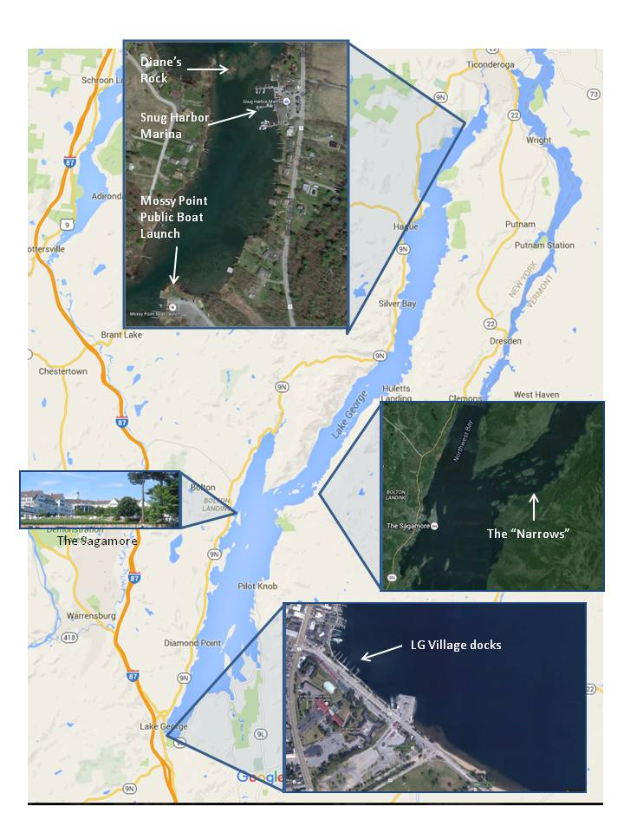**.**

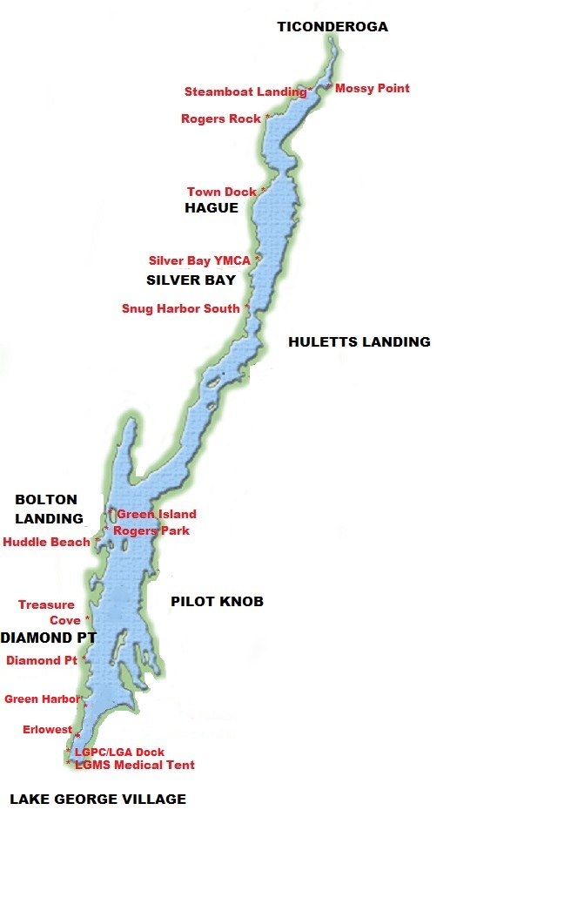**Map 2. Evacuation Points**

**Directions to Moses-Ludington Hospital, Ticonderoga NY**

**IN THE EVENT OF AN EMERGENCY DIAL 911**

Moses-Ludington Hospital

1019 Wicker St, Ticonderoga NY[(518) 585-2831](http://www.mosesludington.com/getpage.php?name=contact)

**9 miles** – about **13 minutes**

**Directions**

1. Head northeast on NY-9N N/Lake Shore Dr toward Ft. Ticonderoga
2. Turn left onto Wicker St
3. Arrive 1019 Wicker St, Ticonderoga, NY

**Map:**

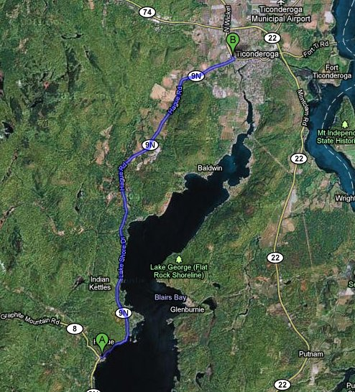

**Directions to Glens Falls Hospital (Regional Trauma Center)**

**IN THE EVENT OF AN EMERGENCY DIAL 911**

Glens Falls Hospital

100 Park St, Glens Falls, NY 12801

[Phone](https://www.google.com/search?q=glens+falls+hospital+phone&stick=H4sIAAAAAAAAAOPgE-LSz9U3MEk3zs4p09LPTrbST87PyUlNLsnMz9PPzssvz0lNSU-NL0jMS80p1s9ILI4vyMjPS7UCkwDEfSXbPwAAAA&sa=X&ved=0CJgBEOgTMBJqFQoTCPTQiIOsmskCFQtcHgodXYkEZA): [(518) 926-1000](javascript:void(0))

**11.8 miles** – about **20 minutes**

**Directions**

Get on I-87 South (6 min from the course Finish area)

Follow I87 to Exit 18 (7 min)

Left at the Exit onto Main Streeet. Take Hudson Ave to Park St in Glens Falls (7 min)

**Map:**

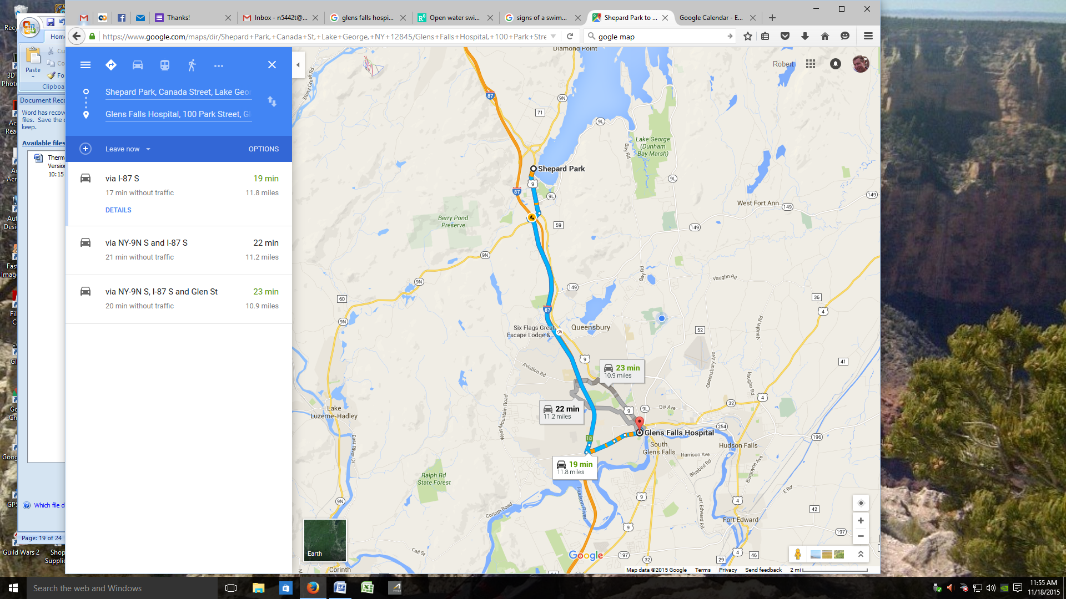



**2016 Contact Information**

Event Director – Robert Singer, [marathon@lakegeorgeswim.com](mailto:marathon@lakegeorgeswim.com), 518-791-1295,

Safety Coordinator – Ruth Dietrich-Quinn, [RDietrich@glensfallsymca.org](mailto:RDietrich@glensfallsymca.org), 518-222-2399

Referee --Deborah Roberts, [debaroberts@gmail.com](mailto:debaroberts@gmail.com), 518-796-9156

Independent Safety Monitor—Harrison Freer, [hcfreer@gmail.com](mailto:hcfreer@gmail.com), 571-243-8239

Warming Tent Supervisor—Tim Ward, PA, [Timward518@hotmail.com](mailto:Timward518@hotmail.com), 518-852-7111.

Finish / Timing / Location Services---Chris Bowcutt, [chris@greenleafracing.com](mailto:chris@greenleafracing.com), 917-371-1108

EMS Coordinator—Anne Green, [agreenreflection@gmail.com](mailto:agreenreflection@gmail.com), 518-796-6405

**Additional Event Safety Contacts:**

Glens Falls Hospital – [518-926-1000](javascript:void(0))

Hague EMS - Renee Swinton - 518-543-8035

Hague Fire Dept – Linda Mury - 518-543-6550

Lake George Coast Guard Aux - Lynn Enny - 518-499-2883

Lake George Park Commission –Joe Johns--518-668-9347

Moses-Ludington Hospital - Head of Nursing - Kristen Thompson - 518 585-3722

Warren County Sheriff’s Department - Lt. Kevin Smith - 518 743-2500

**Addendum A**

**Thirty Years of Surface Water Temperatures in Lake George**

|  |  |  |  |  |  |
| --- | --- | --- | --- | --- | --- |
| **Date** | **Surface Temp C** | **Surface Temp F** | **Date** | **Surface Temp C** | **Surface Temp F** |
| 9/22/1980 | 18.8 | 65.8 | 9/14/2005 | 22.5 | 72.4 |
| 9/16/1981 | 19.5 | 67.1 | 9/15/2006 | 19.2 | 66.6 |
| 9/17/1982 | 18.7 | 65.6 | 9/6/2007 | 20.8 | 69.4 |
| 9/15/1983 | 21.1 | 70.0 | 9/12/2008 | 20.6 | 69.1 |
| 9/25/1984 | 18.4 | 65.1 | 9/22/2009 | 19.7 | 67.5 |
| 9/12/1985 | 19.8 | 67.7 | 9/21/2010 | 19.1 | 66.4 |
| 9/17/1986 | 17.0 | 62.6 |  |  |  |
| 9/16/1987 | 19.3 | 66.7 | mean | 20.0 | 68.0 |
| 9/9/1988 | 20.1 | 68.1 | min | 17.0 | 62.6 |
| 9/7/1989 | 18.8 | 65.8 | max | 24.5 | 76.1 |
| 9/13/1990 | 21.4 | 70.5 |  |  |  |
| 9/11/1991 | 20.7 | 69.2 |  |  |  |
| 9/10/1992 | 20.1 | 68.2 |  |  |  |
| 9/16/1993 | 18.2 | 64.7 |  |  |  |
| 9/19/1995 | 18.5 | 65.2 |  |  |  |
| 9/5/1996 | 24.5 | 76.1 |  |  |  |
| 9/22/1997 | 19.3 | 66.7 |  |  |  |
| 9/28/1998 | 19.2 | 66.6 |  |  |  |
| 9/9/1999 | 22.7 | 72.9 |  |  |  |
| 9/19/2000 | 19.2 | 66.6 |  |  |  |
| 9/20/2001 | 19.7 | 67.5 |  |  |  |
| 9/25/2002 | 21.2 | 70.2 |  |  |  |
| 9/11/2003 | 22.1 | 71.8 |  |  |  |
| 9/21/2004 | 19.5 | 67.0 |  |  |  |

**Addendum B**

**Swimmer in Distress**

**Please read this document, Sign at the bottom to acknowledge your understanding, and return it with your Waiver of Liability.**

Our intent in the Lake George Marathon Swim is to identify swimmers who are on the way toward trouble early enough to avoid an emergency situation. However, we cannot rule out the possibility that a swimmer who may have overestimated their comfort in open water, or at night, or in waves, may swallow water, panic, and begin to drown. Also, we will have many non-swimmers on the water as volunteers. All kayaks and powerboats will be equipped with floating “noodles” to aid someone in the water and throwable rescue rings or tubes. Anyone in distress should be handed one of these devices while the powerboat is configured to pick them up and emergency personnel are notified.

A more likely scenario is that of a swimmer who is injured, fatigued, dehydrated, ill, or hypothermic and is gradually moving toward panic or loss of function. See <http://www.researchgate.net/publication/13067149_Open_water_swimming._Particular_medical_problems> for a summary of potential conditions that may affect swimmers. Lake George has all of these perils except the risk of jellyfish or other marine toxins. What are the signs of to watch for?

1. **Stroke count will decrease**. The Observer shall count strokes for a minute and record the stroke count every half hour on the form in Addendum C. (A “stroke” is a single arm pull). After the first half hour, the stroke count should settle into a very stable rhythm. A departure of 10% is a cause for worry, and a decrease of 20% is reason enough to talk to the swimmer to assess their mental acuity.
2. **Swimmer cannot swim straight, stops frequently, changes strokes or makes changes to their stroke**. These are all signs that something is wrong. It may be a sore shoulder for which the swimmer is compensating, but it could be a sign that the swimmer is approaching the end of their swim.
3. **Conversational assessment**. Talking to the swimmer is the best way to assess their condition, but the kayaker should try to avoid interrupting the swim. Every time the swimmer stops, their generation of body heat decreases, and only a minute or two of stopping is enough to lose critical body heat. At each feeding stop, the kayaker should use the opportunity to talk to the swimmer. The swimmer may have asked for a specific report from the kayaker (e.g. “How far have we gone?”), but the kayaker should assess the swimmer. Some swimmer/support teams use a list of trivial questions to see if the swimmer is alert (e.g. “Who is the President of the United States?” or “What is your dog’s name?”). We supported a swimmer/mathematician who we asked the easy question: “What are the first four terms of the Fibonacci sequence?” The point is, these questions should be easy for the swimmer. If they seem slow or confused they may be hypothermic, dehydrated, or otherwise impaired. Evacuation should be considered.
4. **Physical assessment**. If the swimmer is maintaining a steady stroke count, these questions can be skipped, but if anything seems amiss these questions should be asked at the next feed. The swimmer should be asked specifically, “Are you in pain?” as opposed to “How is it going?” Other important questions are “Are you cold?” and “Are you dizzy?” and “Are your fingers numb?” One early sign of hypothermia is fingers or toes that lose feeling. The hand becomes an immobile club-like appendage. Some people can swim for hours like this, or it could be Raynaud’s Syndrome (<http://www.webmd.com/arthritis/tc/raynauds-phenomenon-topic-overview>). Signs of dehydration may appear similar to those of hypothermia. At each feeding stop, ask the swimmer “did you urinate?” Swimmers should be encouraged to drink their feed and to drink water. Drinking water from Lake George without treatment is done by many of the camps around the Lake. There are some rare intestinal parasites that can be in the water, so rebottled tap water or commercial bottled water is preferred. If a swimmer goes three hours or more without urinating dehydration could become a serious problem.
5. **Asthma**. Swimmers with asthma may ask for their inhalers. These devices may be handed to the swimmer. If a swimmer is not aware of asthma and their breathing becomes labored immediate evacuation should be considered.
6. **Pain**. Pain in the shoulders, knees, elbows, neck, or really anywhere can become debilitating. The swimmer may try to swim through the pain, but they should be reminded that a serious joint injury could force them out of the sport permanently. The decision to end the swim can be made by the swimmer, but it also can be made by the kayaker or boat Captain.

If a swimmer is evacuated, the following procedures shall be followed:

1. If the swimmer is responsive, hand them a noodle or rescue tube while the powerboat maneuvers for a pickup. Crew on the boat should be prepared to assist the swimmer getting up. Expect the swimmer, even if they are in good shape, to be dizzy and to have muscle weakness when they attempt to stand.
2. Notify the EMS Coordinator, who will coordinate with the Event Director and First Responders, if necessary, and will tell you where to proceed.
3. Notify the Event Director or Referee of the swimmer’s disqualification and tell them where you are taking the swimmer.
4. Dry the swimmer, have them remove their wet suit, and get them into a sleeping bag. If they are responsive have them drink warm fluids. Hot packs under the armpits and another person in the sleeping bag should be used to warm a cold swimmer.
5. Be sure to secure all personnel and the kayak before proceeding to the egress point.
6. Remember, the speed limits are 25 MPH at night and 45 MPH in the daytime. Operate the boat with caution.

I have read and will comply with the advice provided above.

_________________________ ___________________________ ________________

PRINT Name Signature Date

**Addendum C**

|  |  |  |  |  |  |  |
| --- | --- | --- | --- | --- | --- | --- |
| **Solo Swimmer Reporting Form** | **Time** | **Latitude** | **Longitude** | **Weather**  **Wnd/Tmp** | **Stroke Rate** | **NOTES**  **(distances, feeds, incidents, etc.)** |
| **Date** |  |  |  |  |  |  |
|  |  |  |  |  |  |  |
| **Swimmer** |  |  |  |  |  |  |
|  |  |  |  |  |  |  |
| **Observer** |  |  |  |  |  |  |
|  |  |  |  |  |  |  |
|  |  |  |  |  |  |  |
| **Lake George Marathon Swim, September 17-18 2016** |  |  |  |  |  |  |
|  |  |  |  |  |  |
|  |  |  |  |  |  |
|  |  |  |  |  |  |  |
|  |  |  |  |  |  |  |
|  |  |  |  |  |  |  |
| **Page of** |  |  |  |  |  |  |

|  |  |  |  |  |  |  |  |
| --- | --- | --- | --- | --- | --- | --- | --- |
| **Relay Team Reporting Form** | **Time** | **Swimmer OUT** | **Swimmer IN** | **Longitude** | **Longitude** | **Weather** | **NOTES**  **(distances, incidents, etc.)** |
| **Date** |  |  |  |  |  |  |  |
|  |  |  |  |  |  |  |  |
|  |  |  |  |  |  |  |  |
| **Team Name** |  |  |  |  |  |  |  |
|  |  |  |  |  |  |  |  |
| **Observer** |  |  |  |  |  |  |  |
|  |  |  |  |  |  |  |  |
|  |  |  |  |  |  |  |  |
| **Lake George Marathon Swim, September 17-18 2016** |  |  |  |  |  |  |  |
|  |  |  |  |  |  |  |
|  |  |  |  |  |  |  |
|  |  |  |  |  |  |  |  |
| **Page of** |  |  |  |  |  |  |  |

1. DO NOT SAY “Over and Out.” Although common in movies, that phrase makes no sense—“Over” means “your turn to talk,” and “Out” means “I’m done with the radio for now.” Thus “Over and Out” really means, “I’m done listening to you but you can talk now.” Although probably harmless it can really annoy people familiar with using radios.